

RAPPORT DE STAGE DE FIN D’ETUDES

5éme Année en Ingénierie Informatique et Réseaux

MASTER MÉTHODES INFORMATIQUES APPLIQUÉES À LA GESTION DES ENTREPRISES (MIAGE) - Parcours Mobiquité, Big Data et intégration de Systèmes (MBDS)

Développement Intégral et Déploiement d'une Plateforme Web de Banque en Ligne : Gestion des Demandes de Prêts et Signatures Électroniques

Réalisé par :

RABII Yahya

Tuteur (s) :

Encadrant Professionnel : Mr. BELAICHER Abdelhadi.

Encadrant Pédagogique : Mme. CHERRABI Mariam.

Au sein de Société Générale Maroc :



Année universitaire : 2023/2024

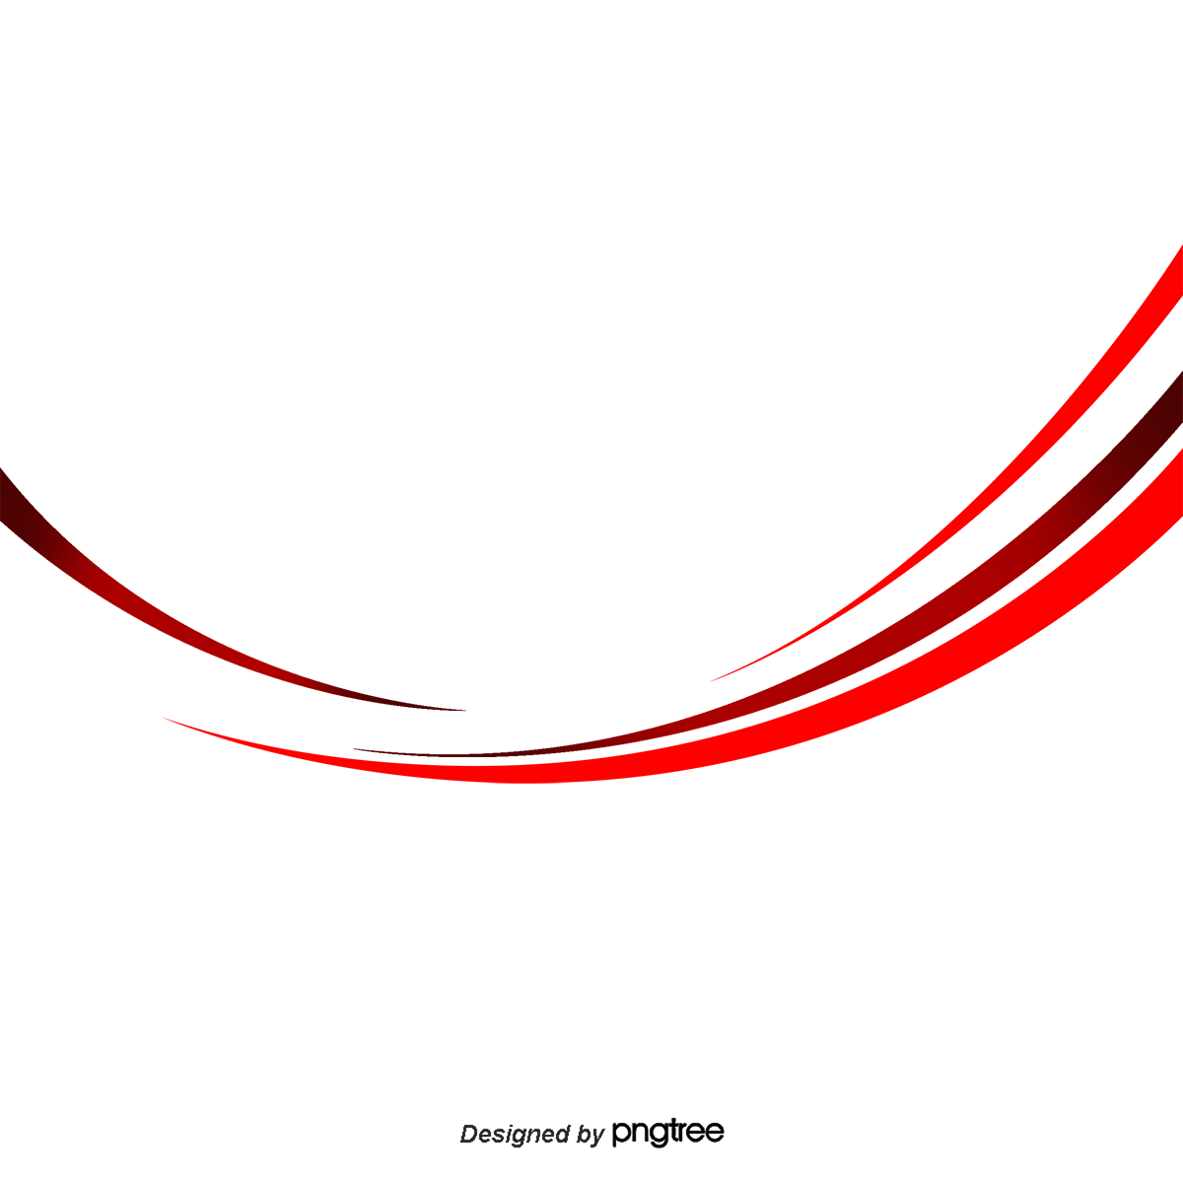

المدرسة المغربية لعلوم المهندس
The Moroccan School of Engineering Sciences
L’École Marocaine des Sciences de l'Ingénieur
End of Studies Project (PFE)
To obtain the state engineering degree in
Computer Science and Network Engineering
option: Information Technology Applied to Business Management (MIAGE).
Master's Degree - Track in Ubiquitous Computing, Big Data and Systems Integration (MBDS).

The End-to-End Creation and Deployment of an
e-Banking Web Platform: Loans Requests and Electronic Signatures
Submitted by: | RABII Yahya
Host Company: | Société Générale Maroc
Supervised By: | Mr. BELAICHER Abdelhadi
Tutored By: | Mme. CHERRABI Mariam



Acknowledgments

This project would not be possible without the help and encouragement of several people to whom I owe my thanks with all my heart and dedicate this work.

I thank my mentor, Mr. BELAICHER Abdelhadi, who always gave me a hand of help and did not hesitate for an instant to put his hand in the dough for the success of this work.

Mr. GUOURCH Othman, our respected DevOps expert, has been a backbone source of support through this project. His professionalism and dedication to making our development and deployment process seamless have been critical to our endeavours’ success. We owe him a colossal vote of thanks for everything he did for us, with continued support in his commitment to excellence.

In this respect, I would also like to extend my special thanks to Mr. BOUZROUR Hamza, our tribe leader, who guided us and, most importantly, shared with us his own experience in the field.

I sincerely thank the staff of Société Générale Maroc, for their assistance and warm welcome, especially the members of the PS Team within the Digital Factory of SGMA.

I also thank Mme. CHERRABI Mariam our tutor for the guidance she offered throughout the period of the internship.

All my professors especially the members of the jury who agreed to evaluate my work.




Résumé

Ce document synthétise mon stage de fin d'études pour l'obtention du diplôme d'ingénieur d'État en informatique et réseaux à l’École marocaine des sciences de l'ingénieur. Le projet principal était le développement d'une plateforme de banque électronique pour la gestion des demandes de prêts et les signatures électroniques, effectué au sein de la Société Générale Maroc.

Pour le développement, nous avons utilisé une architecture de microservices avec Spring Boot pour le backend et Angular 17 pour le frontend. La sécurité a été renforcée grâce à Spring Security et Keycloak. Le stockage des fichiers est géré via MinIO, et la qualité du code a été surveillée avec SonarQube.

Le projet intègre également un système avancé de gestion de logs et de monitoring. Nous avons utilisé Micrometer et Logstash pour la collecte de logs, Elasticsearch pour leur stockage et analyse, et Kibana pour la visualisation. Le monitoring des services est assuré par Prometheus et Grafana, permettant une surveillance en temps réel de la performance et de la santé des applications.

Nous avons également implémenté des fonctionnalités de messagerie électronique, et le monitoring des microservices est facilité par Spring Boot Admin. La documentation de l'API est gérée via OpenAPI.

Au niveau des opérations, nous avons employé Flyway pour la gestion des versions de base de données. L'intégration et le déploiement continus sont réalisés avec Docker, Git, GitHub Actions, et Kubernetes, garantissant un processus de développement agile et réactif.

La phase de recette de l'application est en cours, avec des tests approfondis pour assurer la fiabilité avant le déploiement en production. Ce stage a été une occasion précieuse de mettre en œuvre des solutions technologiques avancées pour améliorer l'efficacité et la sécurité des services bancaires numériques.

Mots clés: Société Générale Maroc, e-banking, Spring Boot, Angular, Spring Security, Keycloak, MinIO, SonarQube, DevOps, Micrometer, Logstash, Elasticsearch, Kibana, Prometheus, Grafana, Spring Boot Admin, OpenAPI, Flyway, Docker, Git, GitHub Actions, Kubernetes.

Abstract

This report summarizes the internship conducted as part of the requirements for obtaining a State Engineer's degree in Computer Science and Networks from the Moroccan School of Engineering Sciences. The primary objective of the internship was to design and develop an e-banking platform for loan applications and electronic signatures at Société Générale Maroc.

The platform was engineered using a microservices architecture, employing Spring Boot for backend services and Angular 17 for the frontend, ensuring high performance and security. Security measures were reinforced using Spring Security and Keycloak. File management was facilitated through MinIO, and code quality was maintained using SonarQube.

Advanced logging and monitoring were integral to the project, with Micrometer and Logstash for log management, Elasticsearch for storage and analysis, and Kibana for visualization. System health and performance monitoring were conducted using Prometheus and Grafana, providing real-time insights.

Email functionalities were implemented, and microservices monitoring was enhanced using Spring Boot Admin. API documentation was managed via OpenAPI. Database version management was handled with Flyway. Continuous integration and deployment processes were streamlined using Docker, Git, GitHub Actions, and Kubernetes, supporting an agile development lifecycle.

The application is currently in the testing phase, undergoing rigorous validation to ensure reliability before production deployment. This internship was a valuable experience, applying theoretical knowledge to real-world challenges and contributing to the digital transformation of banking services.

Keywords: Société Générale Maroc, e-banking, Spring Boot, Angular, Spring Security, Keycloak, MinIO, SonarQube, DevOps, Micrometer, Logstash, Elasticsearch, Kibana, Prometheus, Grafana, Spring Boot Admin, OpenAPI, Flyway, Docker, Git, GitHub Actions, Kubernetes.

TABLE OF CONTENT

List of figures 7
List of Tables 9
List of Acronyms 10
GENERAL INTRODUCTION 11
GENERAL CONTEXT OF THE INTERNSHIP 13
Introduction 13
I. Company Overview 13
1. General introduction 13
2. Société Générale Maroc Logo 14
3. Société Générale Membership 14
4. Société Générale Subsidiaries 15
5. Technical Sheet of Société Générale Maroc 16
6. Shareholders of Société Générale Maroc: 16
II. General Work Framework: 17
III. Project Presentation: 17
1. Project Overview: 17
2. Objectives to Achieve: 17
3. Required Work: 17
Conclusion: 18
REQUIREMENTS ANALYSIS AND SPECIFICATIONS 20
Introduction: 20
I. Preliminary Study: 20
1. Existing System’s Study: 20
2. Proposed Solutions: 22
II. Requirements Specification: 22
1. Functional Requirements: 22
2. Non-Functional Requirements: 23

CONCEPTUAL STUDY 26
Introduction: 26
I. Project Development Life Cycle: 26
II. Project Planning: 28
III. UML Language: 30
1. Introduction to UML: 30
2. Importance of modeling: 30
3. advantages of UML: 30
IV. Concepting with UML: 31
1. Modelling Tool: 31
2. Modeling with Use Case Diagrams: 32
3. Modeling with sequence diagrams: 33
4. Modeling with Class Diagram: 40
Conclusion: 40
THE IMPLEMENTATION 42
Introduction: 42
I. Working environment: 42
1. Hardware environment: 42
2. Software environment: 43
3. Operating System: 43
4. Integrated Development Environment: 43
II. Development: 44
1. Frontend: 44
2. Backend 46
3. Databases and Data administration Tool 58
III. DevOps: 60
1. Containerization Tool 60
2. Version Control Tool 60
3. Container Orchestration Tool 62
1. Continuous delivery GitOps Tool 67
2. Automation Tool 68
3. Proxy, Load balancing Tool 69
4. Logs Management Tools 69
5. Static code Analytics Tool 73
IV. Graphical interfaces and Processes: 77
1. Authentication Process: 77
2. Bank Account Creation Process: 78
3. Loan Request Process 79
4. Loan Validation Process 80
5. Add Beneficiary Process 82
6. Add Transaction Process 83
GENERAL CONCLUSION 85
References 86

List of figures

Figure 1: Société Générale Maroc Logo 14
Figure 2: Société Générale Membership 14
Figure 3: Société Générale Subsidiaries 15
Figure 4:Shareholders of Société Générale Subsidiaries 16
Figure 5: Agile - Scrum Model 27
Figure 6: Jira SGMA Project board 29
Figure 7: The Use Case Diagram 32
Figure 8: The Sequence Diagram (Signup) 33
Figure 9: The Sequence Diagram (Login) 34
Figure 10: The Sequence Diagram (Email Verification) 35
Figure 11: The Sequence Diagram (Authentication) 36
Figure 12: The Sequence Diagram (create Account) 37
Figure 13 : The Sequence Diagram (Add Beneficiary) 37
Figure 14: The Sequence Diagram (Perform Transaction) 38
Figure 15:The Sequence Diagram (Request Loan) 39
Figure 16: The Class Diagram (Full Diagram) 40
Figure 17: IntelliJ Logo 43
Figure 18: Vs Code Logo 43
Figure 19: Angular Logo 44
Figure 20:Angular Framework Features 44
Figure 21: Angular Development Tools 45
Figure 22: Java Logo 46
Figure 23: Maven Logo 46
Figure 24: Maven Architecture 47
Figure 25: Spring Logo 48
Figure 26: Spring Boot Logo 49
Figure 27: Spring Security Logo 50
Figure 28: Spring Security Flow 50
Figure 29: Spring Admin Logo 51
Figure 30: Spring Admin Interface 51
Figure 31: OpenApi Logo 52
Figure 32: OpenApi Documentation Interface 52
Figure 33: Spring Cloud Logo 53
Figure 34: Spring Cloud Architecture 53
Figure 35: Eureka Netflix Logo 54
Figure 36: Eureka Netflix Interface 54
Figure 37: Postman Logo 55
Figure 38: PostMan Interface 55
Figure 39: Keycloak Logo 56
Figure 40: Keycloak Dashboard 56
Figure 41:MinIO Logo 57
Figure 42:MinIO Dashboard 57
Figure 43: H2 Database Logo 58
Figure 44: PostgreSQL Logo 58
Figure 45: FlyWay Logo 59
Figure 46: FlyWay Diagram 59
Figure 47: Docker Logo 60
Figure 48: GitHub Logo 60
Figure 49: Git Logo 60
Figure 50: GitHub Actions Logo 61
Figure 51: GitHub Actions Workflow 61
Figure 52: Kubernetes Logo 62
Figure 53: Kubernetes Components 62
Figure 54: ConfigMap Architecture 63
Figure 55: Kubernetes Service Architecture 64
Figure 56: Sealed Secret Architecture 65
Figure 57: Helm Charts Example 66
Figure 58: Argo CD Logo 67
Figure 59: Argo CD Architecture 67
Figure 60: Ansible Logo 68
Figure 61: Ansible Playbooks Architecture 68
Figure 62: Nginx Logo 69
Figure 63: Elastic Stack 69
Figure 64: Prometheus Logo 70
Figure 65: Prometheus Dashboard 70
Figure 66: Grafana Logo 71
Figure 67: Grafana Dashboard 71
Figure 68: Spring / Prometheus / Grafana architecture 72
Figure 69: Logs Monitoring Architecture. 72
Figure 70: SonarQube Logo 73
Figure 71: SonarQube Dashboard. 73
Figure 72: SonarQube Workflow. 74
Figure 73: Dev Architecture. 75
Figure 74: DevOps Architecture. 76
Figure 75: Authentication process 77
Figure 76: Bank Account Creation Process 78
Figure 77: Loan Request Process 79
Figure 78: Loan Validation Process 80
Figure 79: Add Beneficiary Process 82
Figure 80: Add Transaction Process 83

List of Tables
Table 1:Technical Sheet of Société Générale Maroc 16
Table 2:Agile - Scrum Model 28

List of Acronyms

AGPL: | Affero General Public License
AOP: | Aspect-Oriented Programming
API: | Application Programming Interface
CD: | Continuous Delivery
CI: | Continuous Integration
CNI: | Container Network Interface
CRI: | Container Runtime Interface
CSRF: | Cross-Site Request Forgery
DIFA | Digital Factory
ELK: | Elasticsearch, Logstash, Kibana
GUI: | Graphical User Interface
IAM: | Identity and Access Management
IDE: | Integrated Development Environment
IoC: | Inversion of Control
JDBC: | Java Database Connectivity
JPA: | Java Persistence API
JVM: | Java Virtual Machine
K8s: | Kubernetes
MVC: | Model-View-Controller
ORDBMS: | Object-Relational Database Management System
OS: | Operating System
PNG: | Portable Network Graphics
PS | Platform Services
RAM: | Random Access Memory
RBAC: | Role-Based Access Control
RIB: | Relevé d'Identité Bancaire (Bank Identity Statement)
SGMA | Société Generale Maroc
SLC: | Software Life Cycle
SQL: | Structured Query Language
SQL: | Structured Query Language
SSO: | Single Sign-On
UML: | Unified Modeling Language
XSS: | Cross-Site Scripting

GENERAL INTRODUCTION

In the dynamic landscape of e-banking, the evolution of financial institutions parallels humanity's enduring quest for efficient communication channels. From ancient times to the present day, the relentless pursuit of effective message transmission has spurred innovation and technological progress.

The 20th century witnessed a telecommunications revolution propelled by rapid advancements and the widespread adoption of the Internet. This revolution transformed the way information is transmitted, facilitating swift communication between parties. Today, information flows freely, diversifies, and adopts bidirectional pathways, easily accessible to all.

In our contemporary era, the proliferation of web applications, fuelled by the popularity of computing tablets, has led to exponential growth in mobile application downloads. Within this bustling digital marketplace, telecommunications companies are increasingly investing in e-banking solutions. Société Générale Maroc is among the pioneers in this domain.

For my final studies project, I have been tasked with designing an e-banking web platform to bridge the gap between end-users and banking services. To fulfil this objective, I have structured my report around four key chapters:

- In the first chapter, "General Framework," I have introduced the context of my project.
- In the second chapter, "Analysis and Requirements Specification," I have identified the future system's stakeholders, both functional and non-functional requirements.
- In the third chapter, "Conceptual Study," I have modelled a design with UML diagrams.
- In the final chapter, "Implementation," I present the hardware and software environment, along with the key interfaces of the developed platform and the major deployment processes.


1st Chapter

GENERAL CONTEXT OF THE INTERNSHIP

GENERAL CONTEXT OF THE INTERNSHIP

Introduction

In this chapter, I place my work within its broader context. First and foremost, I have introduced the internship environment through a brief presentation of the hosting organization. Subsequently, I have outlined the overall framework of this project.

Company Overview
In this section, I introduce the hosting organization that proposed this subject.

General introduction

  - Enduring Values
Founded in 1864, Société Générale has built a legacy of financial excellence over more than a century.
Its corporate culture is deeply rooted in values such as integrity, innovation, and customer-centricity,
guiding the bank through economic fluctuations and earning it the trust of millions worldwide.
  - Global Influence
Beyond France, Société Générale's impact spans the globe, with operations in numerous countries.
Through its network of branches and subsidiaries, the bank facilitates international trade and finance,
contributing to global economic development.
  - Resilience and Adaptability
Société Générale has demonstrated resilience and adaptability in response to changing market
dynamics and regulations. By embracing innovation and leveraging technology, the bank remains at
the forefront of the financial industry, continuously enhancing its capabilities.
Société Générale Maroc: Shaping Morocco's Financial Future
  - A Century of Service
Established in 1913, Société Générale Maroc has played a pivotal role in Morocco's economic
development for over a century. Its history is deeply intertwined with the nation's progress, serving as
a driving force for growth and prosperity.
  - Commitment to Inclusion
Guided by values of openness, sharing, and solidarity, Société Générale Maroc is committed to
promoting financial inclusion. Through initiatives such as specialized banking services for unbanked
individuals and support for microcredit, the bank aims to empower marginalized communities,
fostering economic opportunity and social mobility.

Société Générale Maroc Logo


Figure 1: Société Générale Maroc Logo

Société Générale Membership

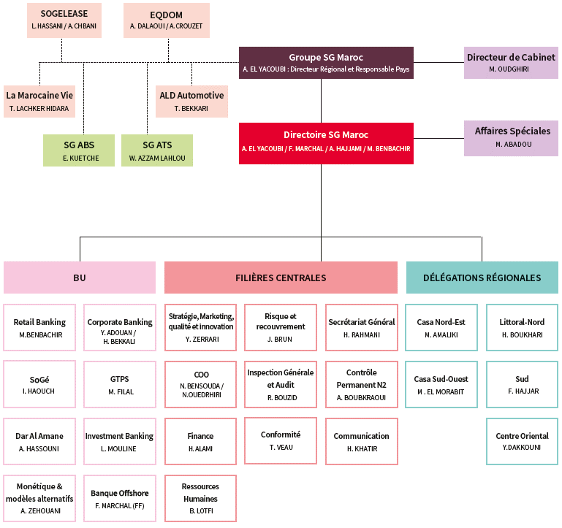
Figure 2: Société Générale Membership

Société Générale Subsidiaries
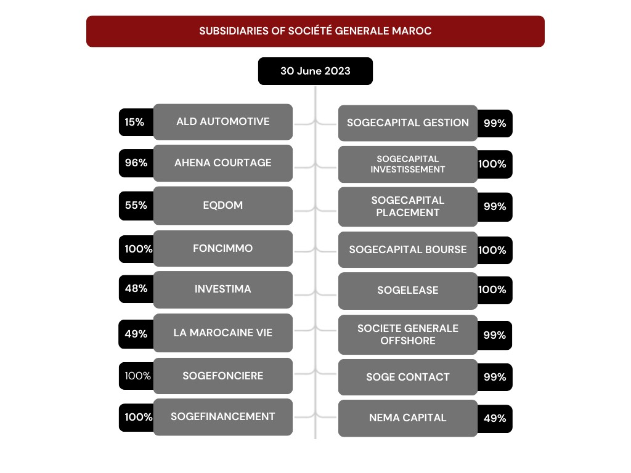
Figure 3: Société Générale Subsidiaries

Technical Sheet of Société Générale Maroc
Table 1:Technical Sheet of Société Générale Maroc
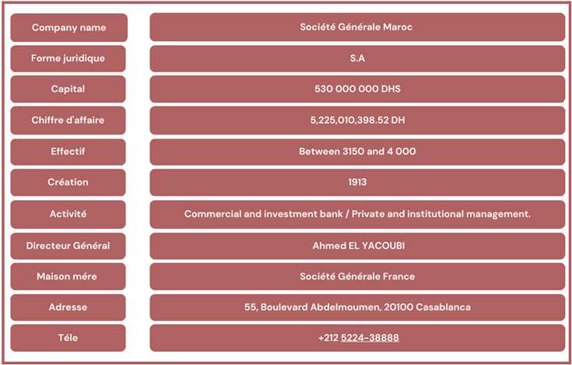

Shareholders of Société Générale Maroc:
Société Generale Maroc is a member of a large family of Subsidiaries:

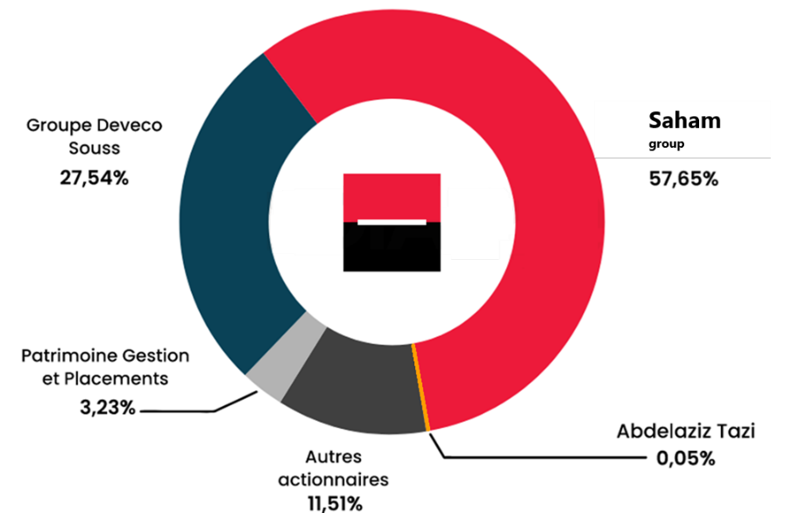
Figure 4:Shareholders of Société Générale Subsidiaries

General Work Framework:

For this internship, the goal is to design and develop a web platform geared towards streamlining banking interactions with end-users. This solution seeks to simplify processes such as loan requests, account creation, and banking transactions, ultimately enhancing the company's overall profitability.

Project Presentation:

Project Overview:
This project is undertaken as part of an internship initiative. The platform is meticulously crafted to ensure compatibility across all devices and web browsers. It offers both users and agency administrators a streamlined approach to their tasks, aiming to boost workplace efficiency.

Objectives to Achieve:
    - Facilitating and organizing employees' work.
    - Ensuring proper customer service.
    - Saving time and achieving customer satisfaction.
    - providing a better work experience through seamless navigation, as a web application is often more ergonomic than using paper

Required Work:
My responsibilities consist of:
      - Contributing to the development of a dynamic web application.
      - Establishing an optimized connection between the platform and the servers.
      - Optimizing performance for a seamless experience across various devices.
      - Integrating synchronization functionalities.
      - Providing comprehensive documentation to simplify the application's usage.
      - Conducting tests to identify and resolve potential compatibility issues

Conclusion:
In this chapter, I have placed this project within its broader context. I began with a general description of the company "Société Générale Maroc". I presented its Logo and its activities. Following that, I introduced the overall framework of this project, starting with a brief overview, the objective to achieve, and the required tasks. I concluded by providing details about the development environment and the timeline.


Requirements Analysis and Specifications
2nd Chapter

REQUIREMENTS ANALYSIS AND SPECIFICATIONS

Introduction:

In this second chapter, I will start by discussing the existing system at "Société Générale Maroc." Through our study we have identified some communication challenges, with suppliers that directly affect efficiency and customer satisfaction. This analysis forms the basis, for introducing a solution aimed at improving service quality.

Preliminary Study:

To ensure the achievement of objectives, it is essential to start with a clear and straightforward view of the various expected needs. Hence, an examination of the existing system will enable me to justify and formulate a solution.

Existing System’s Study:

Existing System’s Description:

The Currently, the company operates with a system that comprises a mix of traditional methods and mobile applications to cater to various banking needs. While these methods have served adequately, they present challenges in terms of efficiency and user experience.
- Loan Request Process:
The current system relies heavily on traditional methods for loan requests. Users must navigate through a series of manual steps, including paperwork and in-person visits to the bank. This process is time-consuming and prone to errors, leading to delays in loan approval and disbursement.
- Banking Transactions and Account Creations:
Banking transactions and account creations primarily occur through the company's mobile app. While the app offers convenience, it segregates these functions from the web browser experience, creating a disjointed user journey. Users must switch between platforms, leading to a fragmented experience and potential confusion.
- Compatibility and Accessibility:
While the mobile app caters to a segment of users, it poses limitations in terms of device
compatibility and accessibility. Not all users may have access to smartphones or prefer mobile banking, thereby excluding a portion of the customer base.
- Customer Satisfaction and Feedback:
The existing system's limitations have been reflected in customer feedback, with complaints about delays, complexities, and inconsistencies in the banking experience. Dissatisfied customers may seek alternative banking solutions, leading to potential loss of market share.

Existing System’s Critique:
- Existing System’s Critique:
Promptly identifying issues within the existing system is crucial for ensuring the company's continued provision of quality service to its clients. A critical examination of the current system reveals several shortcomings that need to be addressed:
- Fragmented User Experience:
The existing system offers a fragmented user experience due to the use of multiple channels for different banking functions. Users must navigate between traditional methods and mobile applications, leading to inconsistency and confusion in the overall banking process.
- Lack of Integration:
There is a notable lack of integration between the various channels used for banking services. The absence of seamless communication between traditional methods and mobile applications results in inefficiencies and delays in processing user requests.
- Limited Accessibility:
The reliance on mobile applications for certain banking functions restricts accessibility for users who may not have access to smartphones or prefer web-based interactions. This limitation excludes a segment of the customer base and hinders the company's ability to reach a broader audience.
- Inefficiency and Delays:
The reliance on manual processes for tasks such as loan requests contributes to inefficiency and delays in service delivery. Paperwork and in-person visits to the bank add unnecessary steps to the process, leading to frustration among users and potentially affecting customer satisfaction.
- Risk of Customer Dissatisfaction:
The cumulative effect of the existing system's shortcomings poses a significant risk of customer dissatisfaction. In today's competitive banking landscape, providing a seamless and user-friendly experience is essential for retaining customers and maintaining a positive brand image.

Proposed Solutions:
To fix the identified issues and ensure the professionalism of services offered by Société Générale Maroc, my aim is to design and develop a comprehensive web platform. This platform will serve as a centralized hub for all banking activities, seamlessly integrating loan requests, account creations, and banking transactions into a unified user experience. By leveraging modern web technologies, such as responsive design and intuitive user interfaces, the platform will be accessible across all devices and web browsers, catering to a diverse range of users. Additionally, I intend to implement robust security measures to safeguard sensitive user information and ensure compliance with regulatory requirements. Through this initiative, I aim to streamline banking processes, enhance user satisfaction, and uphold the company's commitment to professionalism and excellence in service delivery.

Requirements Specification:

Functional Requirements:
The future platform offers the following functionalities to different users:
- For Agency Administrators:
- User Management: Agency administrators have the authority to manage user accounts effectively. This includes functionalities such as adding, modifying, deleting, activating, and deactivating user accounts as needed.
- Loans Management: Administrators can oversee the entire loan process, from application submission to approval or rejection. They have the capability to confirm or reject loan requests based on predefined criteria.
- Access to Histories: Administrators have access to comprehensive histories of loans, users, and accounts. This enables them to track and analyse past activities for better decision-making and auditing purposes.
- Claims Management: Administrators possess the ability to add, delete, and modify claims associated with user accounts or transactions. This feature allows for efficient handling of disputes and resolution processes.
- For End-Users:
- Account Creation: End-users have the freedom to create their accounts seamlessly through the platform. This process includes providing necessary personal information and setting up account preferences.
- Loan Requests: End-users can submit loan requests conveniently through the platform. They have access to a user-friendly interface that guides them through the application process, including providing required documentation and specifying loan details.
- Money Transactions: End-users can perform various monetary transactions directly through their accounts. This includes activities such as fund transfers, bill payments, and deposits, providing them with flexibility and control over their finances.
- Beneficiary Management: End-users have the capability to add, edit, and manage beneficiaries for their accounts. This feature simplifies the process of transferring funds to designated recipients securely and efficiently.

Non-Functional Requirements:
The non-functional requirements represent the rules to adhere to in order to ensure the quality of the future system to be completed and its proper functioning, they can be summarized as follows:

Ergonomic constraints:
The Smooth Learning Curve: The interface design prioritizes a smooth learning curve, enabling users to quickly familiarize themselves with the platform's content and functionalities. Clear navigation paths and intuitive design elements facilitate effortless user onboarding.
Simplicity and Clarity: Simplicity and clarity are paramount in the interface design to ensure an intuitive and easily understandable user experience. Clear labelling, minimalistic design elements, and consistent layout contribute to a user-friendly environment that minimizes cognitive load.
Logical Organization: Interactive elements such as buttons, tables, and forms are organized logically and intuitively to enhance overall ergonomics. This ensures that users can easily locate and interact with the necessary features without encountering confusion or frustration.

Technical constraints:

- Hosting:
- The application is self-hosted on an internal virtual machine (VM), providing a dedicated and controlled environment for hosting the application.
- Scalability Planning: Self-hosting necessitates careful planning for scalability, considering factors such as resource allocation, load balancing, and infrastructure optimization to accommodate growing user demands and evolving business requirements.
- Access Management:
- Access for ordinary users is restricted to authorized employees using a secure open-source identity and access management (IAM) system like Keycloak.
- Two-Factor Authentication (2FA): Implementing 2FA adds an extra layer of security by requiring users to provide two forms of authentication before accessing the system, enhancing protection against unauthorized access and data breaches.
- Role-Based Access Control (RBAC): RBAC allows administrators to assign specific roles and permissions to users based on their job responsibilities, ensuring that individuals have access only to the resources and functionalities necessary for their tasks.

- Administrative Control:
- Administrators are granted comprehensive business control through efficient access management mechanisms, allowing for effective oversight and management of the platform.
- Resource Allocation Policies: Implementing resource allocation policies ensures equitable distribution of computing resources among different applications and users, preventing resource contention and performance degradation.
- Automated Remediation: Implementing automated remediation processes enables administrators to automatically address security vulnerabilities, configuration drifts, and performance issues without manual intervention, improving operational efficiency and reducing downtime.
- Incident Response Plans: Developing incident response plans outlines procedures for identifying, containing, and mitigating security incidents, minimizing the impact of breaches or system compromises on business operations and data integrity.
- Continuous Monitoring: Implementing continuous monitoring solutions allows administrators to proactively detect and respond to security threats, system anomalies, and performance bottlenecks in real-time, enhancing the overall security posture and operational resilience of the platform.

Conclusion:
In this chapter, I conducted a study of the existing system's operations to identify an acceptable solution.
I described both the functional and non-functional requirements of the new system.


3rd Chapter

Conceptual Study

CONCEPTUAL STUDY

Introduction:

“Anticipate before acting, establish plans before building, conceptualize upstream and develop downstream” is the essential approach to follow during the development of an application, as well as for the success of any project.

Indeed, the design phase of an information system holds paramount importance, exerting a direct influence on the overall quality and reliability of the application.

In this chapter, I will introduce the selected project's life-cycle model, thereby providing a methodological framework. Subsequently, I will delve into the design phase in detail, during which I will precisely present the overall architecture of the application. Lastly, I will highlight various diagrams, namely the use case, the sequence diagrams, and the class diagram as well, which will complement this design stage.

Project Development Life Cycle:

The software life cycle, often referred to as the "SLC" encompasses all stages of application development, from conception to eventual release. This structuring aims to establish intermediate steps to confirm software development, ensuring the software's alignment with expressed needs and verifying the development process by maintaining consistency in adopted methodologies. To achieve optimal realization, I introduced the agile methodology, specifically the Scrum methodology, an approach that emerged in the 1990s.

Within this approach, each stage is designed to be flexible and adaptive. Instead of rigidly segmented phases, Scrum operates through iterations known as "sprints." Each sprint, typically of short duration, aims to produce a functional version of the software. The Scrum approach promotes close collaboration among team members, encouraging open and constant communication.

At the core of Scrum lies the "Product Backlog," a dynamic list of items to be accomplished that evolves based on user feedback and changing priorities. At the start of each sprint, the team selects backlog items to address, creating the "Sprint Backlog" that guides sprint efforts. Key Scrum roles, such as the "Scrum Master" and "Product Owner," work synergistically to ensure the success of each sprint and the achievement of objectives.

At the end of each sprint, a "Sprint Review" is held to demonstrate completed work to stakeholders. This is followed by a "Sprint Retrospective" that allows the team to analyse the past sprint and identify improvements for future iterations.

The Scrum approach within the agile framework offers exceptional flexibility to adapt to project evolution and changing requirements. It promotes transparency, team engagement, and continuous delivery of features, making it a relevant methodology for complex and dynamic software development environments
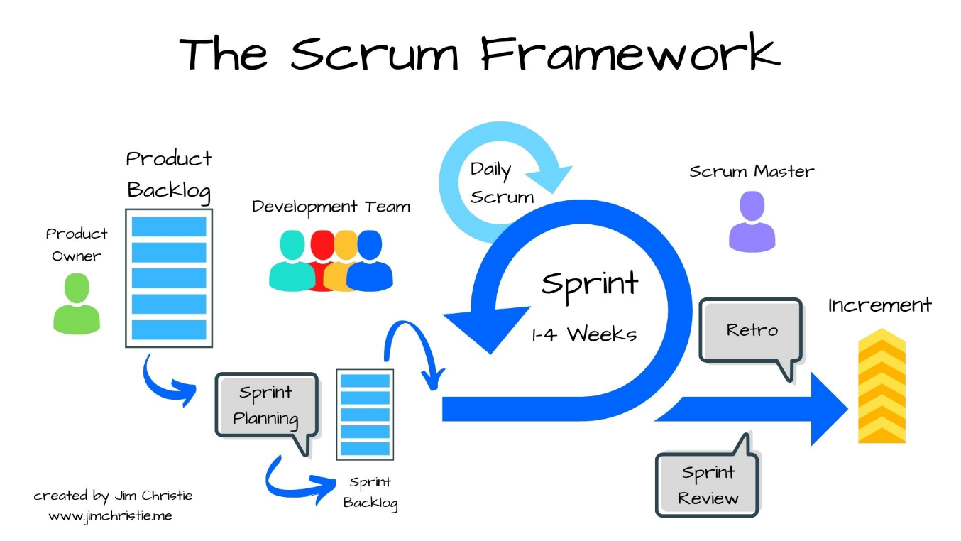
Figure 5: Agile - Scrum Model

Project Planning:

Table 2:Agile - Scrum Model
 | Tasks | starts date | end date | Status
Initiation Process | 03-20-2024
 | Project Presentation | 03/20/2023 | 03/22/2024 | Done
 | Gathering business need | 03/25/2024 | 03/29/2024 | Done
 | Conception | 04/01/2024 | 04/19/2024 | Done
 | Prototyping | 04/01/2024 | 04/19/2024 | Done
 | Initiation | 04/22/2024 | 05/14/2025 | Done
 | Determination of services | 04/22/2024 | 04/24/2028 | Done
 | Creation of the Core Project | 04/25/2024 | 05/10/2024 | Done
 | Initiation on GitLab (selfhosted) | 04/25/2024 | 05/10/2024 | Done
 | Functional scoping meeting | 05/13/2024 | 05/13/2024 | Done
 | Evaluation of the proposed solution | 05/14/2024 | 05/14/2024 | Done
 | Backend Development | 05/15/2024 | 09/06/2024 | Done
Sprint 1  Config Service | Sprint Planning | 05/15/2024 | 05/15/2024 | Done
 | Micro service Development | 05/16/2024 | 05/23/2024 | Done
 | Internal Review and Improvement | 05/24/2024 | 05/27/2024 | Done
 | Sprint Review | 05/27/2024 | 05/27/2024 | Done
 | Retrospective | 05/28/2024 | 05/28/2024 | Done
Sprint 2  Discovery Service Admin Service | Sprint Planning | 05/29/2024 | 05/29/2024 | Done
 | Micro service Development | 05/30/2024 | 06/07/2024 | Done
 | Internal Review and Improvement | 06/07/2024 | 06/10/2024 | Done
 | Sprint Review | 06/10/2024 | 06/10/2024 | Done
 | Retrospective | 06/11/2024 | 06/11/2024 | Done
Sprint 3  Gateway Service Authentication Service | Sprint Planning | 06/12/2024 | 06/12/2024 | Done
 | Micro service Development | 06/13/2024 | 06/21/2024 | Done
 | Internal Review and Improvement | 06/24/2024 | 06/26/2024 | Done
 | Sprint Review | 06/26/2024 | 06/26/2024 | Done
 | Retrospective | 06/27/2024 | 06/27/2024 | Done
Sprint 4  Account Service | Sprint Planning | 06/28/2024 | 06/28/2024 | Done
 | Micro service Development | 07/01/2024 | 07/09/2024 | Done
 | Internal Review and Improvement | 07/10/2024 | 07/12/2024 | Done
 | Sprint Review | 07/15/2024 | 07/15/2024 | Done
 | Retrospective | 07/16/2024 | 07/16/2024 | Done
Sprint 5  Client Service | Sprint Planning | 07/17/2024 | 07/17/2024 | Done
 | Micro service Development | 07/18/2024 | 07/25/2024 | Done
 | Internal Review and Improvement | 07/26/2024 | 07/29/2024 | Done
 | Sprint Review | 07/31/2024 | 07/31/2024 | Done
 | Retrospective | 08/01/2024 | 08/01/2024 | Done
Sprint 6  Contract Service | Sprint Planning | 08/02/2024 | 08/02/2024 | Done
 | Micro service Development | 08/05/2024 | 08/12/2024 | Done
 | Internal Review and Improvement | 08/13/2024 | 08/15/2024 | Done
 | Sprint Review | 08/16/2024 | 08/16/2024 | Done
 | Retrospective | 08/19/2024 | 08/19/2024 | Done
Sprint 7  Loan Service | Sprint Planning | 08/22/2024 | 08/22/2024 | Done
 | Micro service Development | 08/23/2024 | 08/31/2024 | Done
 | Internal Review and Improvement | 09/02/2024 | 09/04/2024 | Done
 | Sprint Review | 09/05/2024 | 09/05/2024 | Done
 | Retrospective | 09/06/2024 | 09/06/2024 | Done

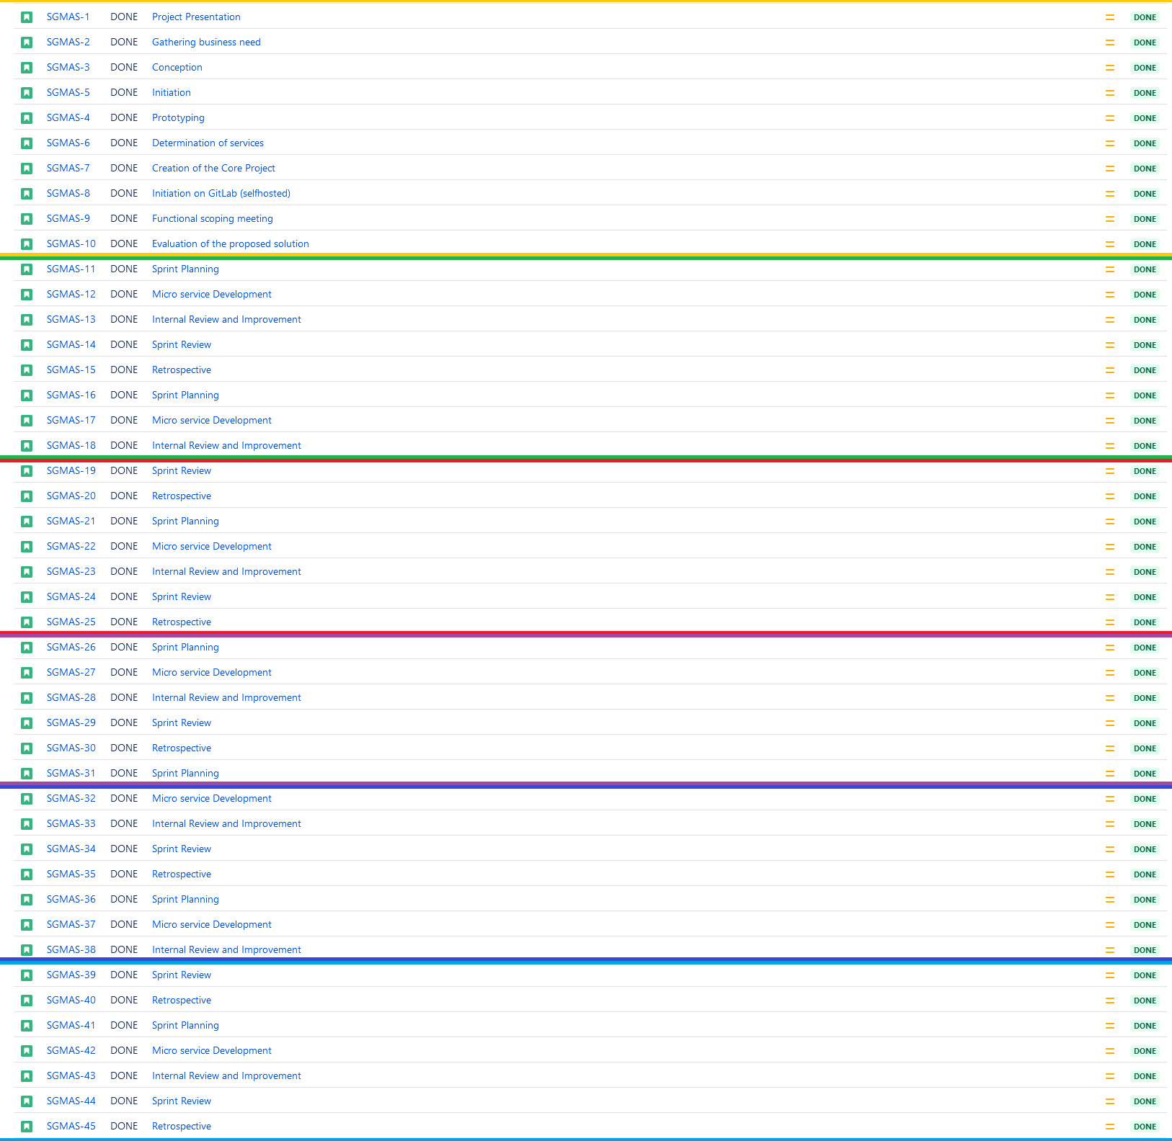
Figure 6: Jira SGMA Project board

UML Language:

Introduction to UML:
UML (Unified Modeling Language) is a graphical language for modeling data and processes. It's a form of object-oriented Modeling used in software engineering. UML serves various objectives which makes it an accurate communication tool:
- Understanding and describing requirements.
- Specifying a system.
- Establishing software architecture.

Importance of modeling:

The use of conceptual Modeling in the development of an information system allows for a more adequate consideration of application needs and provides an abstract representation of certain aspects of physical and human systems.

advantages of UML:
UML is a formal and standardized language it.
- gains precision.
- motivates the use of tools.
- enhances stability and consistency.

UML standardizes object concepts, and its graphical representation enable the expression of an object-oriented solution, simplifying the comparison and assessment of solutions. UML frames object analysis not only represents object concepts but implies an analytical approach that iteratively reproduces an object solution through diagrams, which support abstraction.
UML diagrams are a graphical representation, and different views correspond to diagrams that are distributed according to their static or dynamic aspects:

- Static aspects:

- Use case
- Class

- Dynamic aspects:

- Sequences

Concepting with UML:

Modelling Tool:


PlantUML, is an open-source tool that allows you to create diagrams using a simple and intuitive textual language. It supports various types of diagrams, including UML diagrams, flowcharts, network diagrams, and more. With PlantUML, you can quickly and easily generate diagrams by writing code in a plain-text format, which is then automatically rendered into graphical representations.
The strength of PlantUML lies in its simplicity and versatility. It provides a concise syntax for defining elements and relationships in diagrams, making it accessible to users of all skill levels. Additionally, PlantUML is highly customizable, allowing you to tailor the appearance of your diagrams to suit your specific needs.
PlantUML diagrams can be generated in various formats, including PNG, SVG, PDF, and more, making them suitable for inclusion in documentation, presentations, and other materials. Overall, PlantUML is a powerful and efficient tool for creating professional-quality diagrams quickly and easily.

Modeling with Use Case Diagrams:
- Use Case (General)

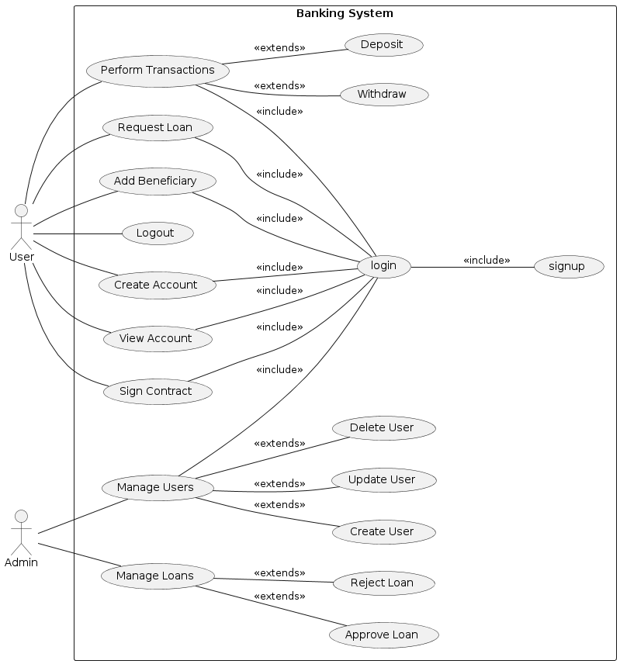
Figure 7: The Use Case Diagram

Modeling with sequence diagrams:

- Signup

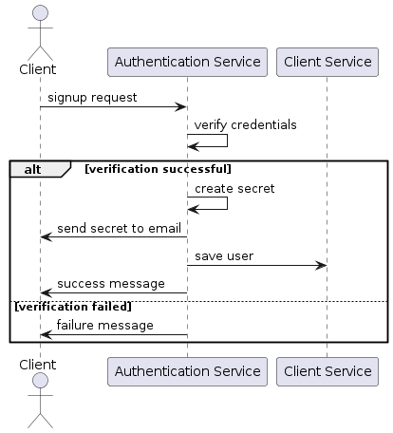
Figure 8: The Sequence Diagram (Signup)

- Login:

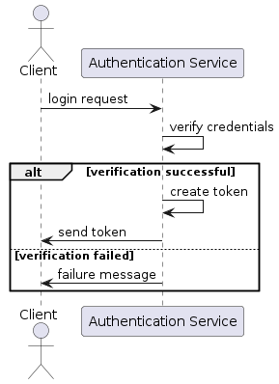
Figure 9: The Sequence Diagram (Login)

- Email Verification:

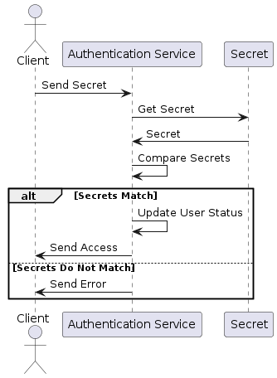
Figure 10: The Sequence Diagram (Email Verification)

- Authentication

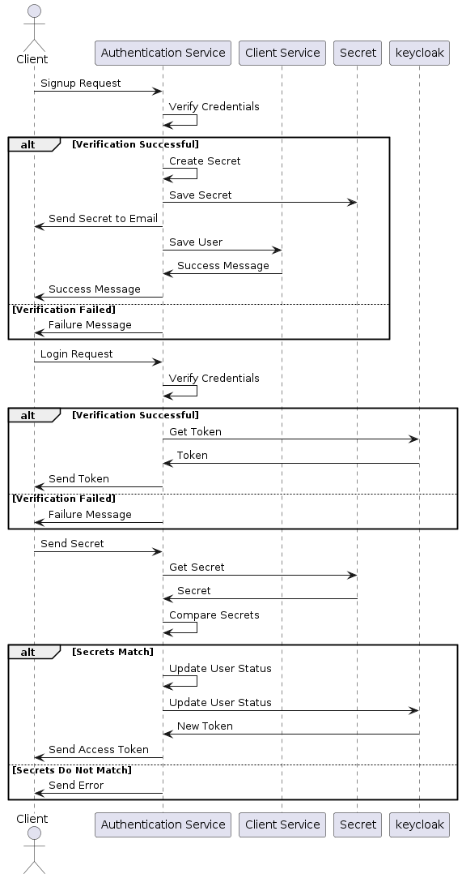
Figure 11: The Sequence Diagram (Authentication)

- Create Account

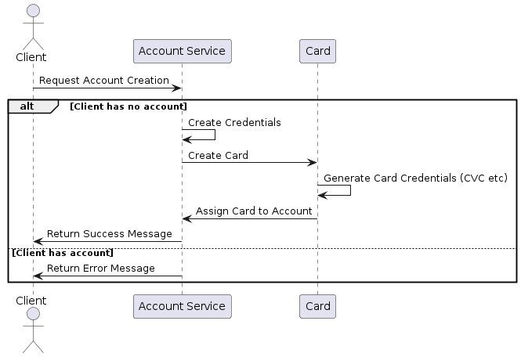
Figure 12: The Sequence Diagram (create Account)

- Add Beneficiary

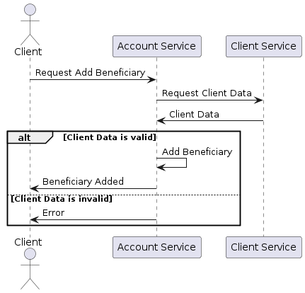
Figure 13 : The Sequence Diagram (Add Beneficiary)

- Perform Transaction:

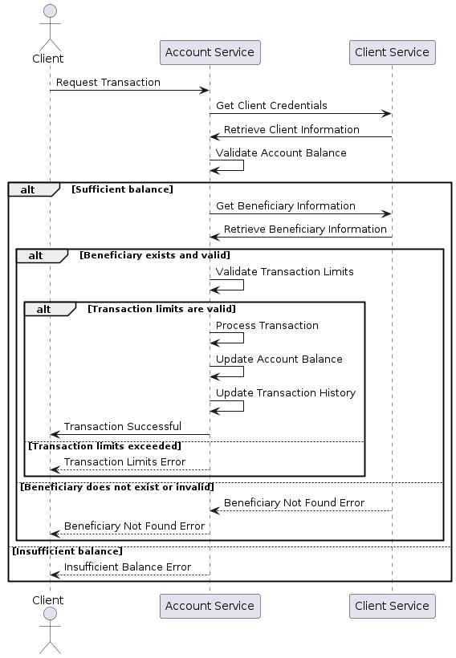
Figure 14: The Sequence Diagram (Perform Transaction)

- Loan verification

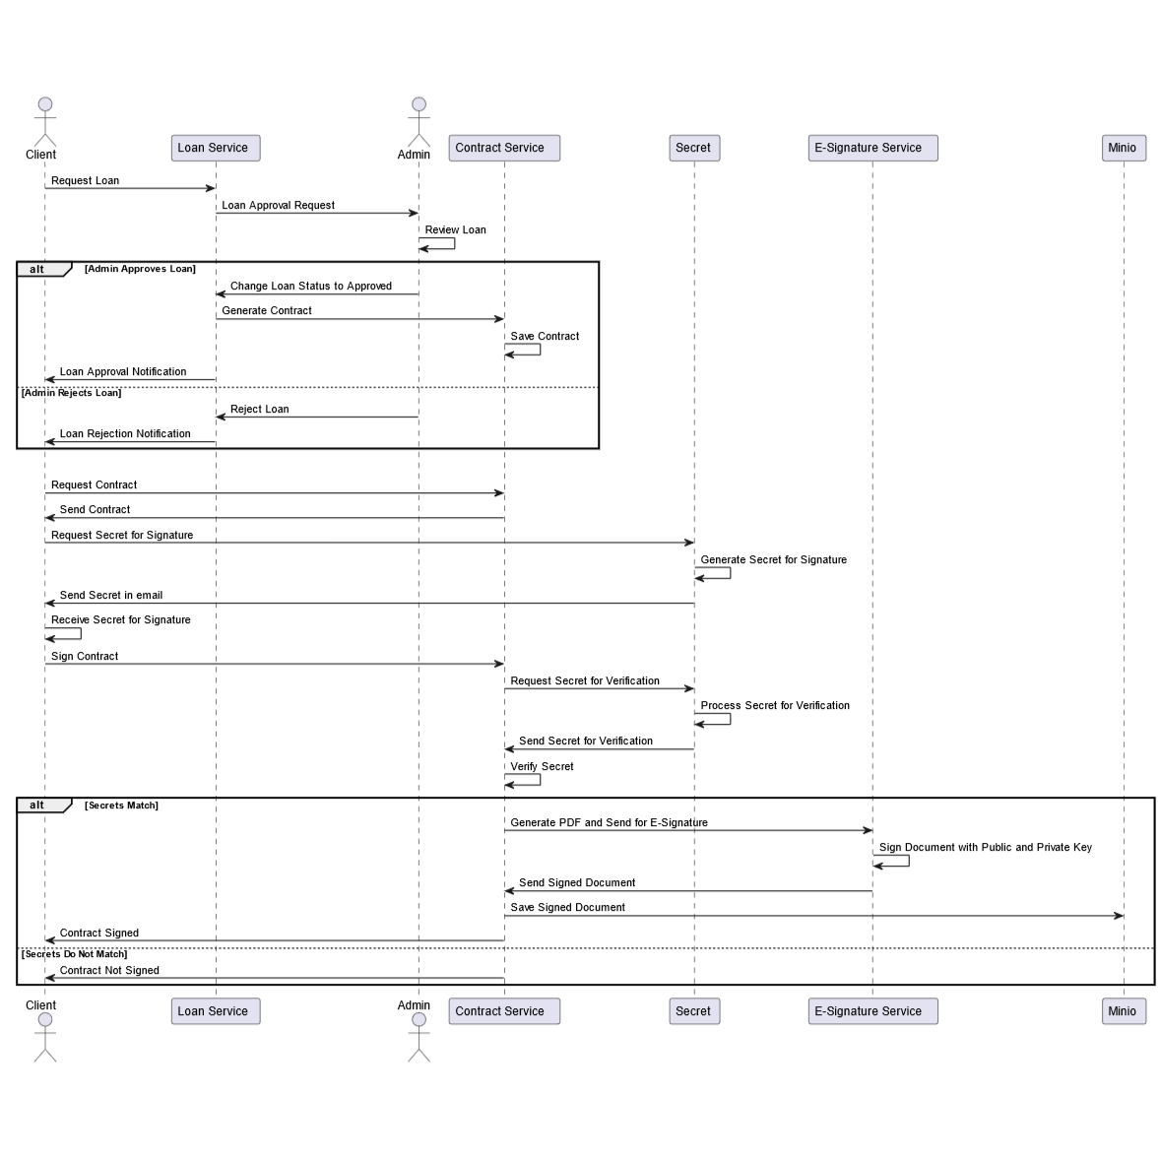
Figure 15:The Sequence Diagram (Request Loan)

Modeling with Class Diagram:

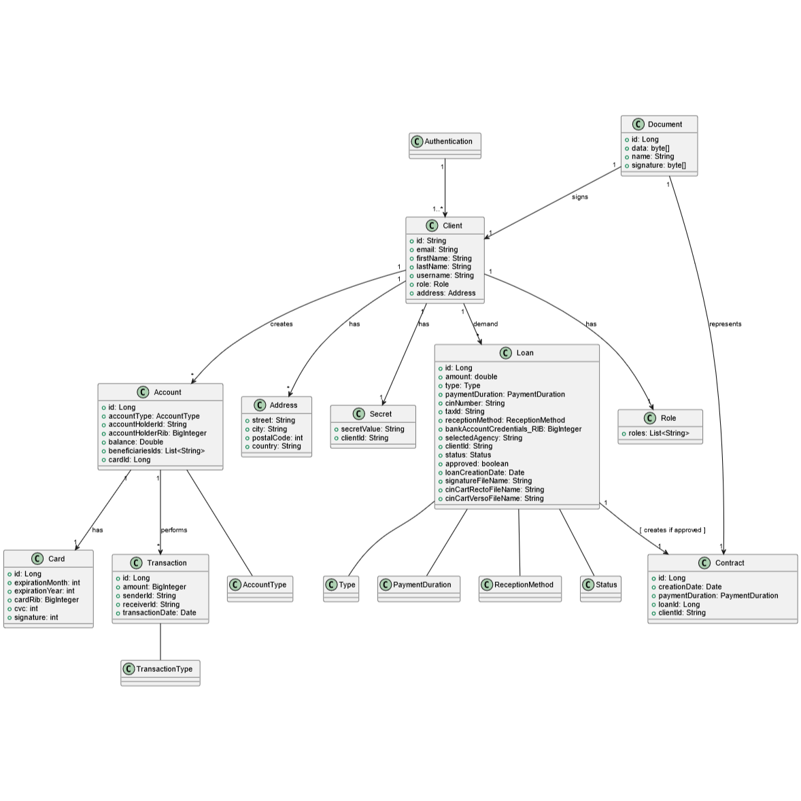
Figure 16: The Class Diagram (Full Diagram)

Conclusion:

This chapter was devoted to UML modeling of the system. I presented different diagrams of the use case diagram, and sequences to specify in detail the functional, dynamic and static aspects of the system. In the next chapter, I will present the development and testing of this system.



4th Chapter

THE
IMPLEMENTATION

THE IMPLEMENTATION

Introduction:

I have now reached the final phase of my report. This last step is of paramount importance as it materializes all the theories presented earlier. To begin, I will present the software production environment. Then, I will introduce the DevOps environment as well then, I will highlight several key interfaces of my solution, as well as some scripts that I have identified as particularly crucial.

Working environment:
Within this section, I will emphasize the various hardware and software tools essential to the development process of my application.

Hardware environment:

I will mention the specifications of the computers on which I developed the solution, as they can provide insight into the working conditions.
The application was developed on two laptops with the following main specifications:
- 1st Laptop
- Name: HP
- Processor: Intel® Core™ i8-10210U (1.6 GHz base frequency, up to 4.2 GHz)
- Installed Memory (RAM): 12.00GB (7.89GB usable)
- System Type: 64-bit Operating System
- 2nd Laptop

- Name: Asus ROG Strix G15
- Processor: AMD Ryzen™ 9 6900HX Mobile Processor (8-core/16-thread, 20MB cache)
- Installed Memory (RAM): 16.00GB DDR4-4800 SO-DIMM
- System Type: 64-bit Operating System

Software environment:
Throughout this section, I will list the various tools used for the study and implementation of our application during this project.

Operating System:
I used the following operating systems:
- 1st Laptop: Microsoft Windows 10 Professional
- 2nd Laptop: Microsoft Windows 11 Professional

Integrated Development Environment:

- IntelliJ

IntelliJ IDEA is an Integrated Development Environment (IDE) for Java and Kotlin designed to maximize developer productivity. It does the routine and repetitive tasks for you by providing clever code completion, static code analysis, and refactoring’s, and lets you focus on the bright side of software development, making it not only productive but also an enjoyable experience.

Figure 17: IntelliJ Logo

- Visual Studio Code

Visual Studio Code (VS Code) is a lightweight, open-source code editor developed by Microsoft. It supports numerous programming languages and frameworks, making it a favourite among developers. Key features include built-in Git integration, IntelliSense for smart code completions, and a rich extension ecosystem. VS Code also offers robust debugging tools and a customizable interface, enhancing productivity and streamlining workflows. It's available on Windows, macOS, and Linux. The logo features a blue, abstract "infinity" symbol, representing its endless possibilities and continuous improvement. development.


Figure 18: Vs Code Logo

Development:

Frontend:

Development Tools and Technologies:

Technologies:
    - Angular Framework:

Angular is a TypeScript-based free and open-source single-page web application framework run on Node.js. It is developed by Google and by a community of individuals and corporations.

Figure 19: Angular Logo
    - Angular Framework Key Features:

- One Page Application: Angular supports the development of single-page applications.
- Data Binding & Fastest Load: It provides efficient data binding and fast load times.
- Simplified MVC Pattern: Uses a simplified Model-View-Controller architecture.
- Cross Platform: Enables development across various platforms.
- Simple & Expressive: The framework is designed to be simple and expressive.
- Speed & Performance: Optimized for high speed and performance.
- Maximum Users: Capable of handling a large number of users.
- Flexible Development: Offers flexibility in the development process.
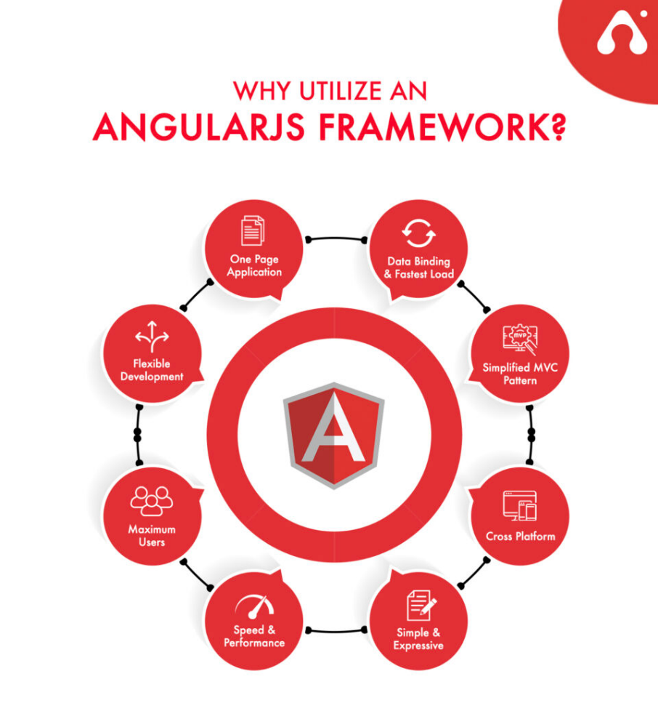
Figure 20:Angular Framework Features

Tools:

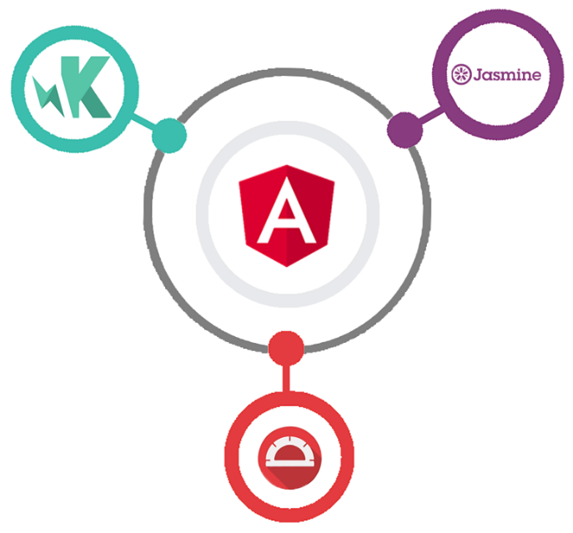
Figure 21: Angular Development Tools


Jasmine is a behaviour-driven testing framework considered as the best from the angular development tools. Jasmine testing tool is mostly used with the Karma tool. Jasmine testing tool is doesn’t rely on browsers and exclude external dependencies. Jasmine testing tool allows the angular developers to read, write and test the angularjs code easily. The Jasmine testing tool is an open-source testing tool and free to use.

Protractor is an end-to-end test framework and open-source framework for developing Angularjs applications. Protractor is a combination of several technologies like Mocha, Cucumber, Selenium, and Jasmine. Protractor provides the testing of real browsers and tests like a user. Protractor tools are developed by Google. Protractor is free of cost angularjs testing tool.

Karma is one of the best angularjs development tools and developer’s favourite testing angularjs applications. Karma is known as the perfect testing environment used for testing the applications on real browsers and real devices such as phones and tablets. Karma is an open-source angular development tool to use.

Backend

Development Tools and Technologies:

Technologies:

    - Java Programing language:

Java is a versatile, object-oriented programming language introduced in 1995. Known for its "write once, run anywhere" capability, Java applications are compiled into bytecode that runs on any system with a Java Virtual Machine (JVM). Its syntax, influenced by C and C++, is designed to be simpler and reduce errors.
Java supports key object-oriented principles and includes a rich standard library for extensive functionality. Widely used in web development, enterprise applications, and mobile apps, Java's robust ecosystem and continuous updates make it a powerful and enduring tool for developers.


Figure 22: Java Logo

    - Maven:

Maven is a powerful build automation tool primarily used for Java projects. It simplifies the process of building, managing, and understanding dependencies, ensuring consistent builds, and automating various tasks related to project management.


Figure 23: Maven Logo

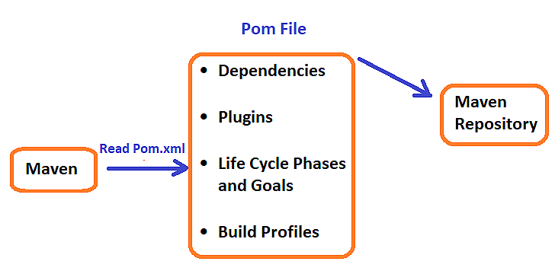
Figure 24: Maven Architecture

Maven operates using the POM file as a central configuration. Maven reads the pom.xml to understand the project's dependencies, plugins, lifecycle phases, goals, and build profiles. It then interacts with the Maven Repository to fetch any required dependencies or plugins, ensuring that the project has all it needs to build successfully. This process automates and simplifies the build management, making Maven a powerful tool for Java developers.

- Spring Framework:

Spring is an MVC framework for building enterprise-level web applications. It is based on Java, Kotlin, and Groovy. First launched in 2002, it was created to simplify the development of software solutions on the popular Oracle’s Java EE stack, which itself is quite complex and not convenient to use.
One of the main differentiators of Spring is its infrastructural support at the application level. Thus, developers can focus their efforts on building business logic without worrying about writing code to ensure compatibility with specific deployment environments. For example, Spring is not tied to a particular programming paradigm or model, so it can be used as a development framework for different applications.
The current version of Spring is 6.1.x released on November 16, 2023.
Spring is made up of many modules out of the box. Below we describe the main ones:
- Spring IoC: Manages dependencies and configurations using Dependency Injection, creating objects via a unique method or constructor.
- Spring MVC: Implements the MVC pattern, separating model, view, and controller, which simplifies development and maintains clear architectural layers.
- Spring AOP: Supports Aspect Oriented Programming for functionality that can't be separated using OOP, simplifying the management of cross-cutting concerns.
- Spring Data JDBC: Provides access to relational databases without the complexity of JPA, executing SQL queries only when repository methods are called.
- Spring Web Flow: Based on Spring MVC, it enables implementation of web application flows, preserving application states with controlled behaviour.
- Spring Security: Framework for creating complex authentication and authorization mechanisms, suitable for projects of all sizes.
- Spring Test: Manages Spring IoC containers, injects dependencies, handles transaction management for integration tests, and provides base classes for test creation.

Figure 25: Spring Logo

- Spring Boot Framework:

Spring Boot framework is an extension to Spring itself, which makes working with Spring much easier and faster, providing developers with a set of utilities that automate Spring configuration. In a nutshell, Spring Boot is not a tool for automatic code generation but a plugin (although often referred to as a framework) for a project build automation system.
Specifically, Spring Boot packages dependencies into starter packages, automatically configures applications with JAR dependencies and creates a web server that allows applications to run locally. The first version of Spring Boot was released in April 2014.
One of its main features are:
- import the necessary Spring modules and the web container library
- connect the necessary third-party libraries that are compatible with the version they work with.
- configure DAO components (data sources, transaction management, etc)
- configure the components of the web layer (resource manager, view resolver, etc)
- specify the class for loading the completed configurations.
- simplifies and fastens the creation and deployment of Spring-based projects;
- helps to manage dependencies and modules loading;
- automates the procedure of interaction with the built-in server;
- automatically creates and configures a database.

Figure 26: Spring Boot Logo

- Spring Security:

Spring Security is a powerful framework that provides comprehensive authentication and authorization capabilities for Java applications. It supports a wide range of security features, including user authentication, role-based access control, and protection against common vulnerabilities like CSRF and XSS. With its flexible and customizable architecture, developers can easily integrate complex security requirements into their projects, making it suitable for applications of all sizes, from small web apps to large enterprise systems with stringent security policies. Spring Security's integration with other Spring modules ensures seamless security management across the entire application.

Figure 27: Spring Security Logo

- Spring Security Flow:

When a user enters credentials, an authentication filter in Spring Security intercepts the request and converts the details into an authentication object. The Authentication Manager then identifies the appropriate authentication provider (e.g., database, OAuth, LDAP). The Authentication Provider, containing business logic, uses User Details Service (defining the user schema) and Password Encoder (handling password encoding/decoding) to validate the input.
Once validated, the Authentication Provider updates the authentication object with user validity, roles, and authorities, then passes it back to the Authentication Manager and Authentication Filter. The authentication object is stored in the Security Context within the Spring container. For subsequent requests, Spring Security validates the token in the authentication object to ensure it is valid.
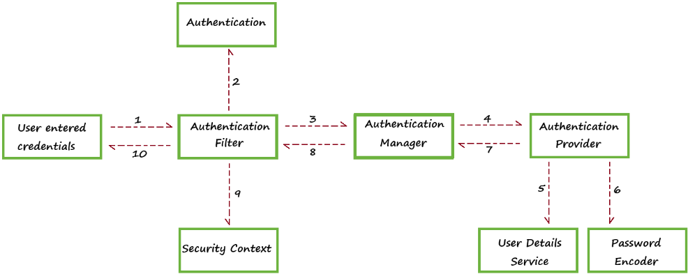
Figure 28: Spring Security Flow

- Spring Admin:

Spring Boot Admin is a web application, used for managing and monitoring Spring Boot applications. Each application is considered as a client and registers to the admin server. Behind the scenes, the magic is given by the Spring Boot Actuator endpoints.

Figure 29: Spring Admin Logo

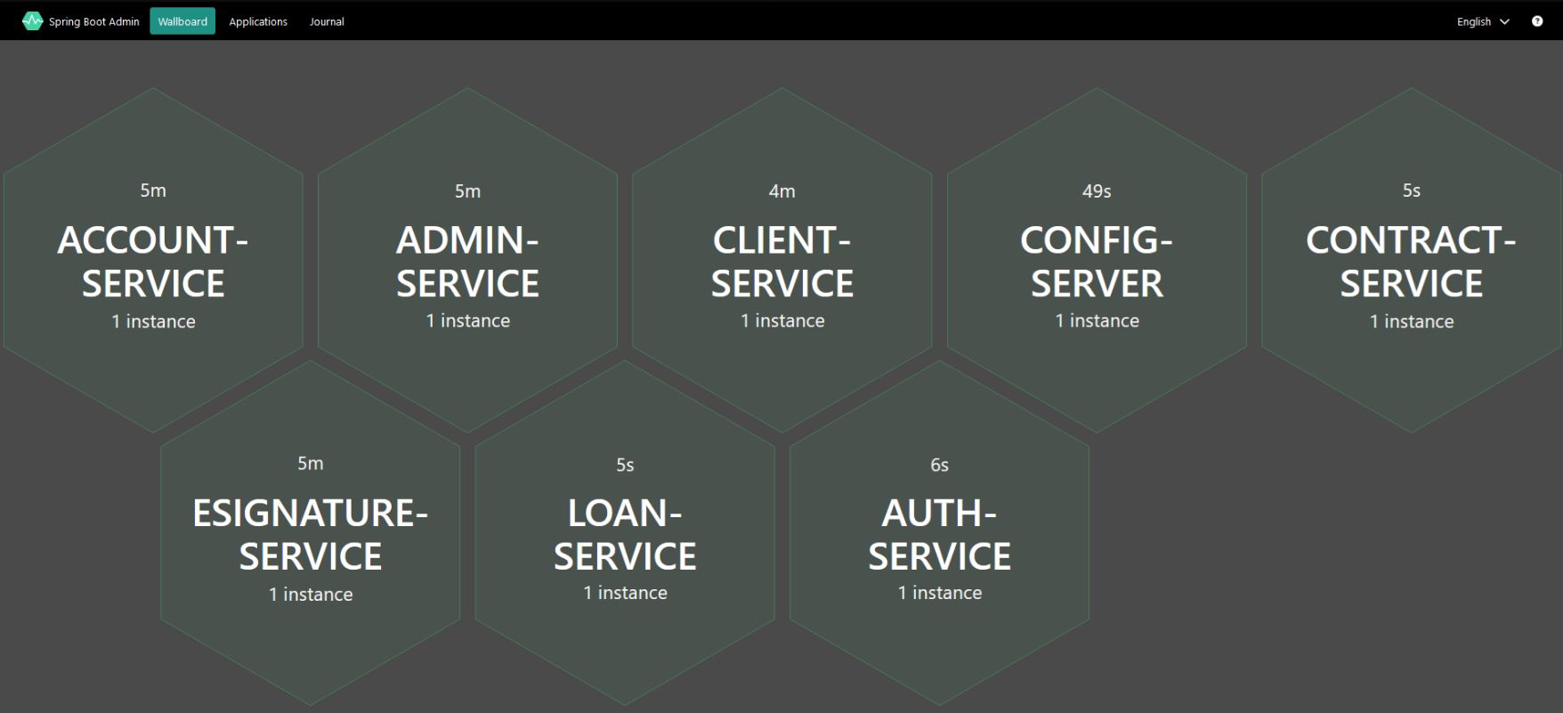
Figure 30: Spring Admin Interface

- Open API Documentation:
I integrated Swagger into my project to streamline the generation of routing documentation for my microservices. The process was straightforward and involved several key steps. First, I added the Swagger UI and Swagger Core libraries to the project's dependencies, ensuring they were properly installed. Then, I configured the gateway to display the documentation for each microservice.
To make this documentation accessible and user-friendly during the development stage, I seamlessly integrated it into our project. Developers can easily explore and test the microservices endpoints through Swagger's interactive UI, which I embedded directly into the application. This integration provides a user-friendly interface for API interaction and testing.

Figure 31: OpenApi Logo

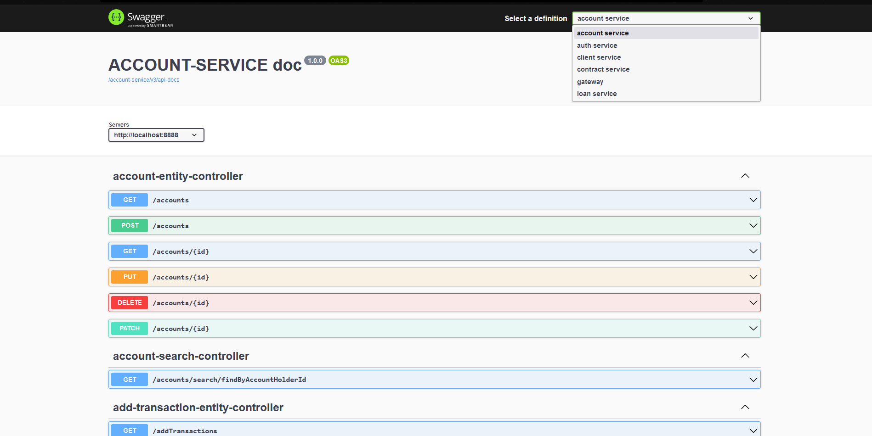
Figure 32: OpenApi Documentation Interface

- Spring Cloud:

Spring Cloud provides tools for developers to quickly build some of the common patterns in distributed systems (configuration management, service discovery, circuit breakers, intelligent routing, micro-proxy, control bus, short lived microservices and contract testing). Coordination of distributed systems leads to boiler plate patterns, and using Spring Cloud developers can quickly stand-up services and applications that implement those patterns. They will work well in any distributed environment, including the developer’s own laptop, bare metal data centres, and managed platforms such as Cloud Foundry.


Figure 33: Spring Cloud Logo

- Spring Cloud Architecture:

In the cloud, applications can’t always know the exact location of other services. A service registry, such as Netflix Eureka, can help. Spring Cloud provides Discovery Client implementations for popular registries such as Eureka, and even Kubernetes' built-in system. There’s also a Spring Cloud Load Balancer to help you distribute the load carefully among your service instances.
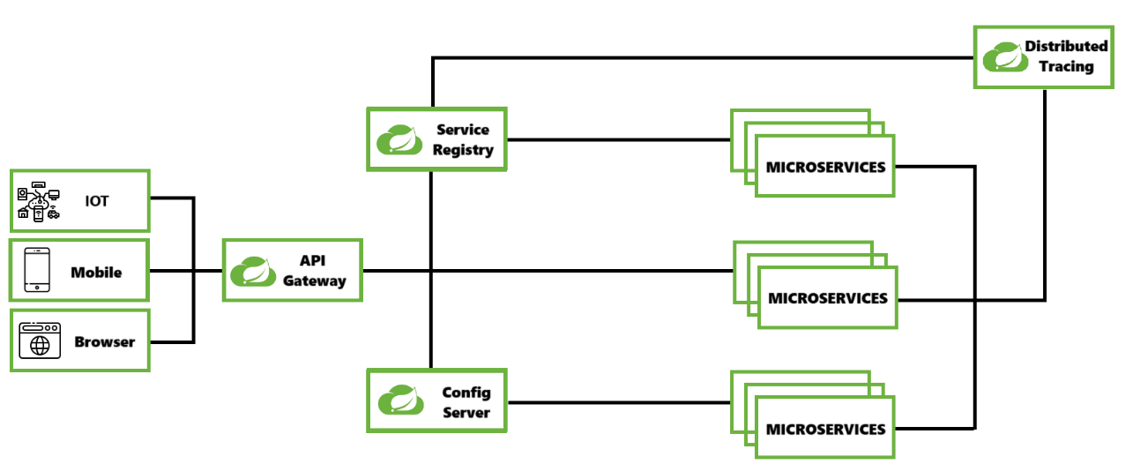
Figure 34: Spring Cloud Architecture

- Eureka Netflix Discovery:

Eureka Discovery is a crucial component in microservices architecture, developed by Netflix as part of the Netflix OSS suite. It functions as a service registry, allowing microservices to dynamically register themselves and discover other services within the system. When a microservice starts up, it registers its network location (IP address, port, etc.) with Eureka, making itself available for discovery by other services. This capability enables load balancing, failover, and the dynamic scaling of services, improving the resilience and scalability of applications. Eureka also performs periodic health checks on registered services to ensure they are available and removes any that fail these checks. The logo for Eureka is a stylized green letter "E," resembling a wave or signal, representing its role in facilitating communication and discovery within microservices ecosystems.

Figure 35: Eureka Netflix Logo

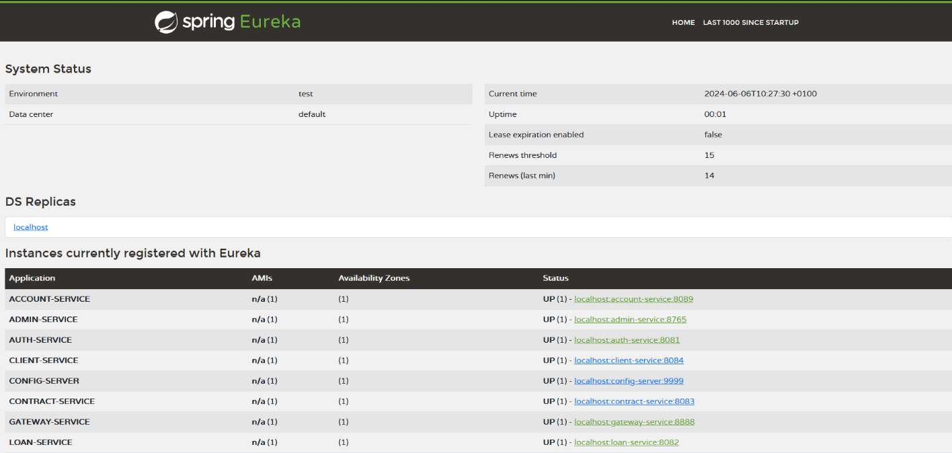
Figure 36: Eureka Netflix Interface

Tools:

- Postman:

Postman is a popular API (Application Programming Interface) development tool that enables developers to design, build, test, and debug APIs. Initially developed as a browser extension, it has evolved into a comprehensive platform that supports various methods like GET, POST, PUT, and DELETE. Postman simplifies each step of the API lifecycle and streamlines collaboration among development teams by providing features such as automated testing, environment management, and mock servers. Its user-friendly interface allows for easy sending of requests, viewing of responses, and writing scripts. Postman is widely used in modern software development for ensuring that APIs perform as intended and meet the needs of applications they power.


Figure 37: Postman Logo
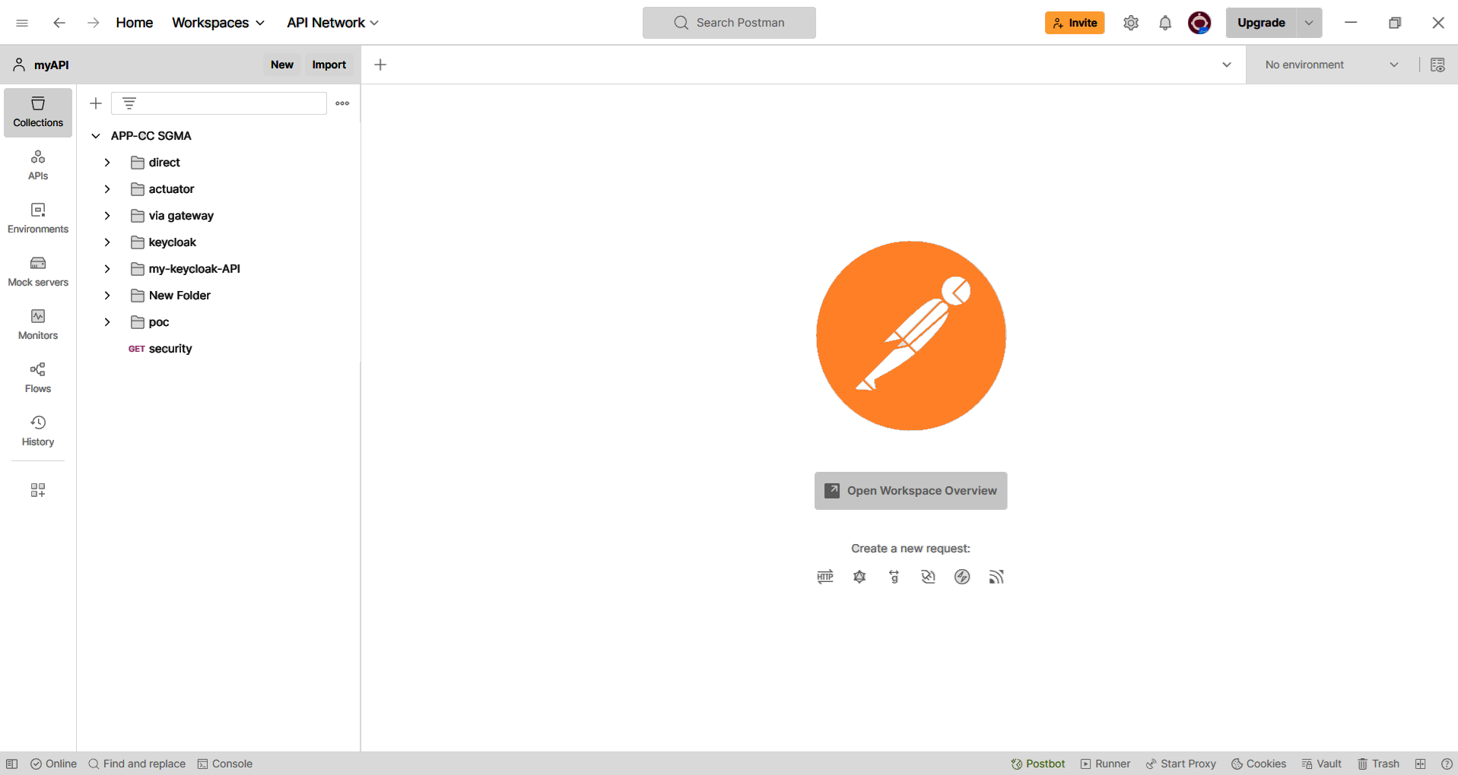
Figure 38: PostMan Interface

- Keycloak Access Management Server:

Keycloak is an open-source Identity and Access Management (IAM) tool. Being an Identity and Access Management (IAM) tool, it streamlines the authentication process for applications and IT services.
The purpose of an IAM tool is to ensure that the right people in a company have appropriate access to resources. It usually enables the implementation of Single Sign-On (SSO), identity federation, and strong authentication.
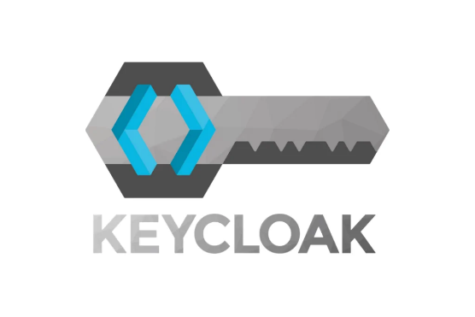
Figure 39: Keycloak Logo

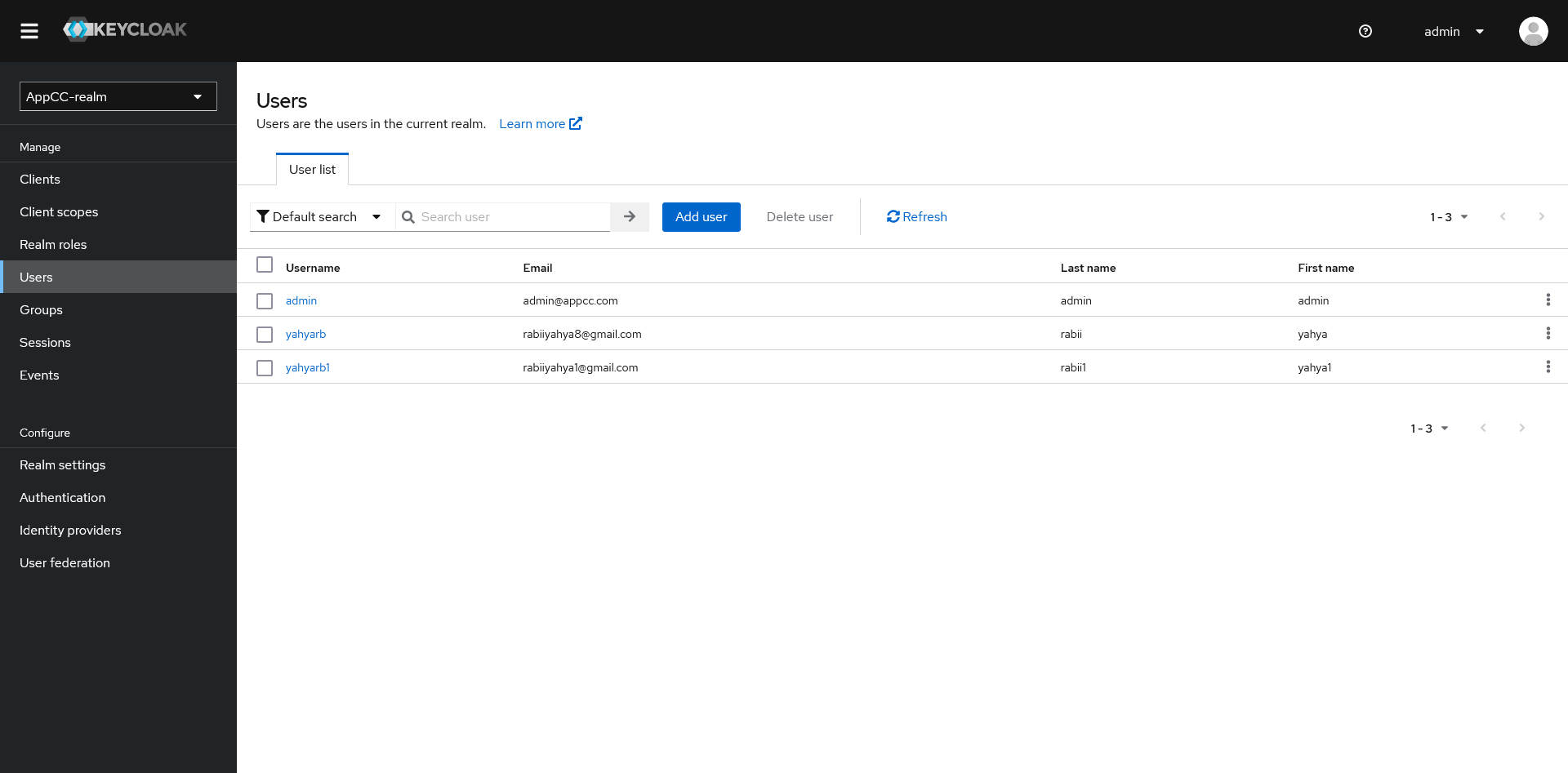
Figure 40: Keycloak Dashboard

- MinIO Object Storage:

MinIO is a high-performance, S3 compatible object store. It is built for large scale AI/ML, data lake and database workloads. It is software-defined and runs on any cloud or on-premises infrastructure. Min-IO is dual-licensed under open-source GNU AGPL v3 and a commercial enterprise license.

Figure 41:MinIO Logo

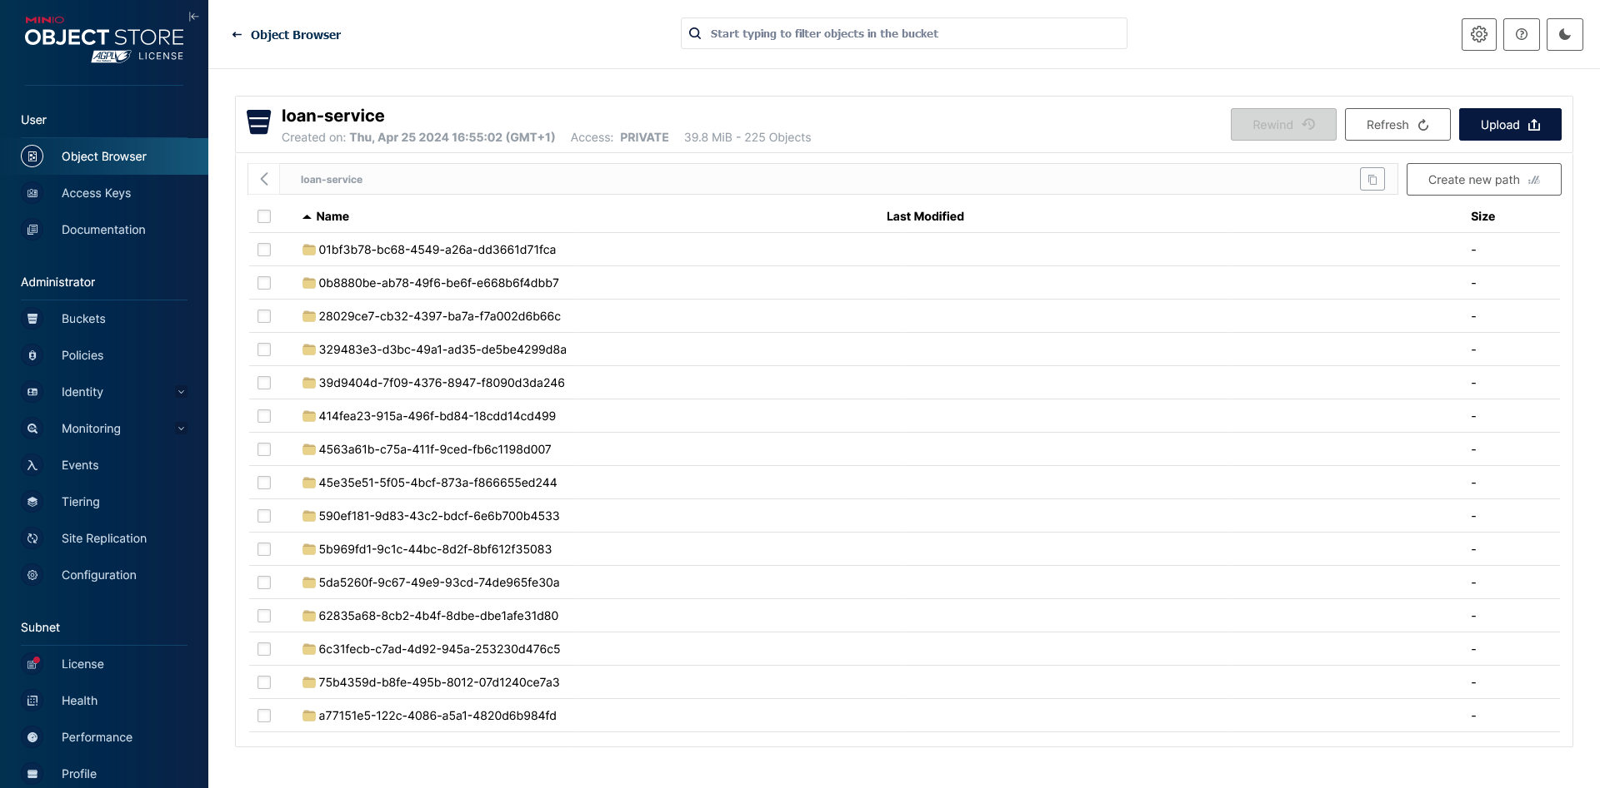
Figure 42:MinIO Dashboard

Databases and Data administration Tool

- H2 Database

H2 Database is a fast, open-source relational database management system written in Java. It is known for its lightweight and in-memory capabilities, making it ideal for development, testing, and small-scale production environments. H2 supports standard SQL and provides a robust set of features, including a web-based console for managing databases, embedded and server modes, and compatibility with JDBC and ODBC. Its ease of use and minimal configuration requirements make it a popular choice for developers needing a reliable database solution.

Figure 43: H2 Database Logo

- PostgreSQL

PostgreSQL is a powerful, open-source object-relational database management system (ORDBMS) known for its robustness, extensibility, and standards compliance. Developed by a global community of developers, PostgreSQL supports both SQL and JSON querying, making it suitable for a wide range of applications from simple web apps to complex data warehousing. Key features include ACID compliance, advanced indexing, full-text search, and support for stored procedures. It also offers a strong emphasis on data integrity and correctness. The PostgreSQL logo features an elephant, symbolizing its strength, reliability, and capacity to handle large amounts of data.

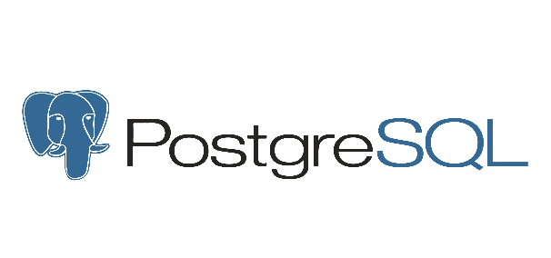
Figure 44: PostgreSQL Logo

- FlyWay

Flyway is a robust database migration tool that simplifies version control for your database schema. It enables you to manage and track changes to your database structure using versioned scripts, ensuring consistency across different environments. By automating the migration process, Flyway helps maintain a reliable and repeatable deployment pipeline, making it easier to handle schema evolution and manage database changes alongside application updates.

Figure 45: FlyWay Logo

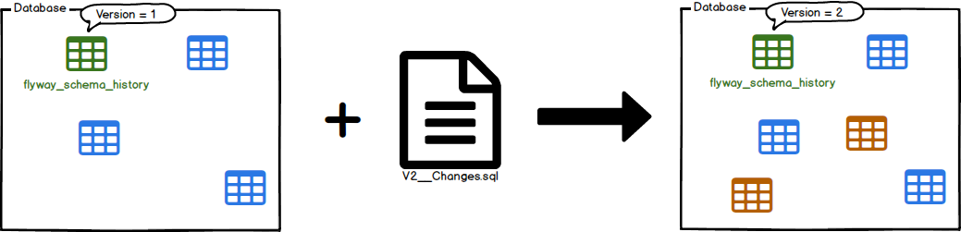
Figure 46: FlyWay Diagram

DevOps:

Containerization Tool

Docker:
Docker is a game-changing virtualization tool that packages applications and their dependencies in isolated containers, ensuring compatibility and consistent execution across different environments. It accelerates deployment, streamlines management, and allows for flexible application scalability.
In my project, I used Docker to seamlessly install and manage a SQL Server database within a containerized environment. By encapsulating the SQL Server instance, its configuration, data, and dependencies in a self-contained container, I was able to ensure consistent and reproducible deployment, regardless of the deployment environment. This modular approach enhances efficiency, portability, and deployment consistency, while simplifying application management and maintenance.
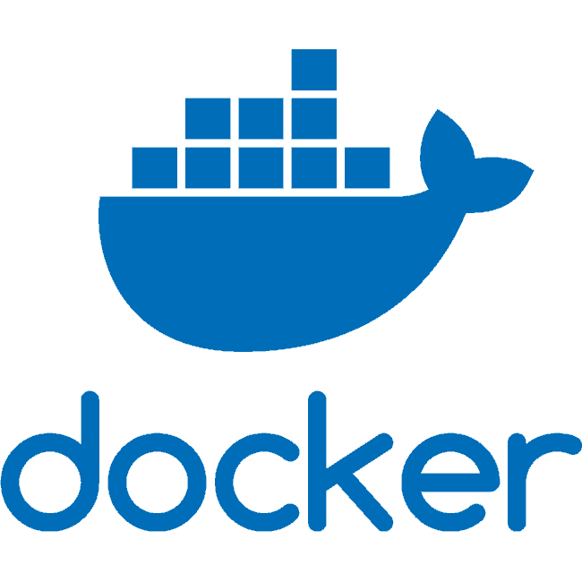
Figure 47: Docker Logo

Version Control Tool

Git/GitHub:
Git, paired with the GitHub platform, represents a crucial pillar for collaborative management and traceability in software development. Git provides an advanced mechanism for tracking changes made to source code, allowing developers to work concurrently on separate branches and seamlessly merge their contributions. GitHub acts as a centralized platform to host, share, and collaborate on Git projects. This enables teams to track code evolution, conduct reviews and discussions, and manage issues transparently. The combination of Git and GitHub promotes agile workflows, efficient project management, and detailed change history making it an essential component of modern development processes.


Figure 48: GitHub Logo
Figure 49: Git Logo

GitHub Actions:
GitHub Actions is a continuous integration and continuous delivery (CI/CD) platform that allows you to automate your build, test, and deployment pipeline. You can create workflows that build and test every pull request to your repository, or deploy merged pull requests to production.


Figure 50: GitHub Actions Logo

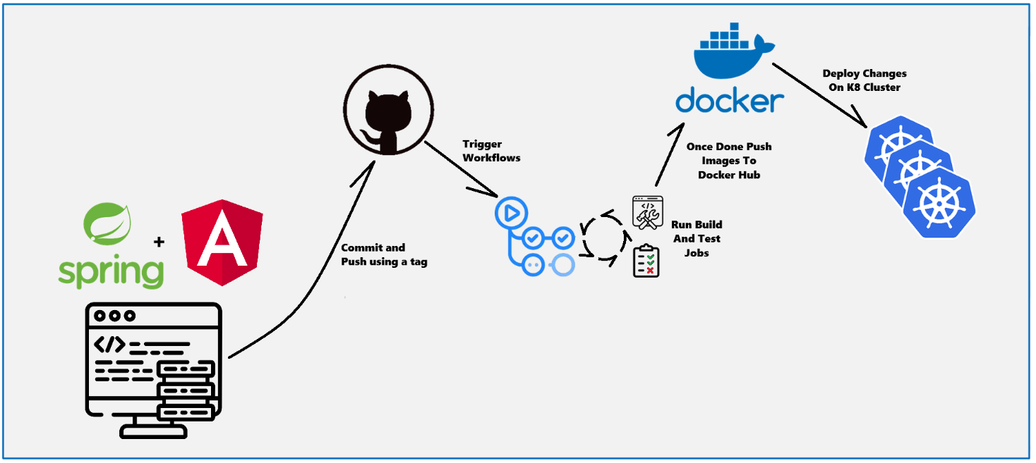
Figure 51: GitHub Actions Workflow

Container Orchestration Tool

Kubernetes:
Kubernetes is a powerful container orchestration tool that automates the deployment, scaling, and management of containerized applications. It ensures high availability, load balancing, and efficient resource utilization across a cluster of machines. Kubernetes simplifies complex container operations by providing features such as automated rollouts and rollbacks, self-healing, and secret management.
In my project, I used Kubernetes to manage and orchestrate multiple microservices running in Docker containers. By deploying these containers in a Kubernetes cluster, I achieved seamless scalability, efficient resource allocation, and improved fault tolerance. Kubernetes' robust orchestration capabilities enabled automatic scaling based on demand, simplified updates and rollbacks, and ensured the high availability of services. This approach significantly enhanced the reliability, scalability, and manageability of the application, facilitating streamlined operations and maintenance.

Figure 52: Kubernetes Logo
- Kubernetes Components:
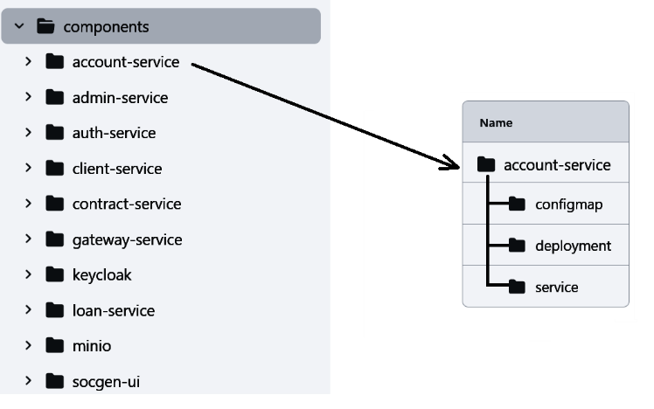
Figure 53: Kubernetes Components

- Config Map
Kubernetes lets you store and manage your configuration and sensitive data in ConfigMaps. A ConfigMap is a key-value store used to manage configuration data separately from application code. It allows you to decouple environment-specific configuration from container images, making applications more portable and easier to manage. ConfigMaps can be used to store configuration settings, command-line arguments, environment variables, and more. They can be injected into pods as environment variables, command-line arguments, or configuration files. This approach enhances flexibility and maintainability, enabling you to change configurations without rebuilding container images.

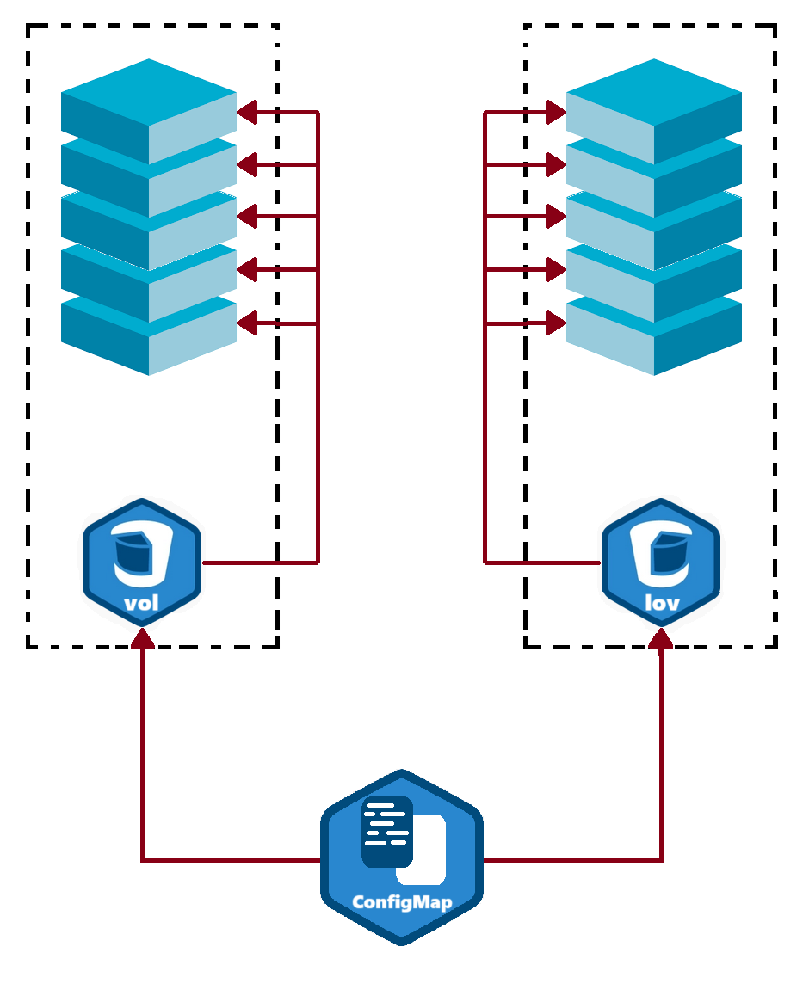
Figure 54: ConfigMap Architecture

- Deployment
Kubernetes Deployment manifest defines the desired state for a set of Pods running a containerized application. It includes configuration for the number of replicas, container images, environment variables from ConfigMaps, health probes, and image pull secrets. The Deployment ensures that the specified number of application instances are running and managed within the cluster, automatically handling updates and restarts as necessary.

- Services
In Kubernetes, a Service is a method for exposing a network application that is running as one or more Pods in your cluster.
A key aim of Services in Kubernetes is that you don't need to modify your existing application to use an unfamiliar service discovery mechanism. You can run code in Pods, whether this is a code designed for a cloud-native world, or an older app you've containerized. You use a Service to make that set of Pods available on the network so that clients can interact with it.
Kubernetes Services provide a stable IP address and DNS name to access a set of Pods. They abstract the underlying Pods, ensuring a consistent endpoint for accessing applications even as Pods are created and destroyed. Services facilitate load balancing, enabling efficient distribution of traffic across multiple Pods.

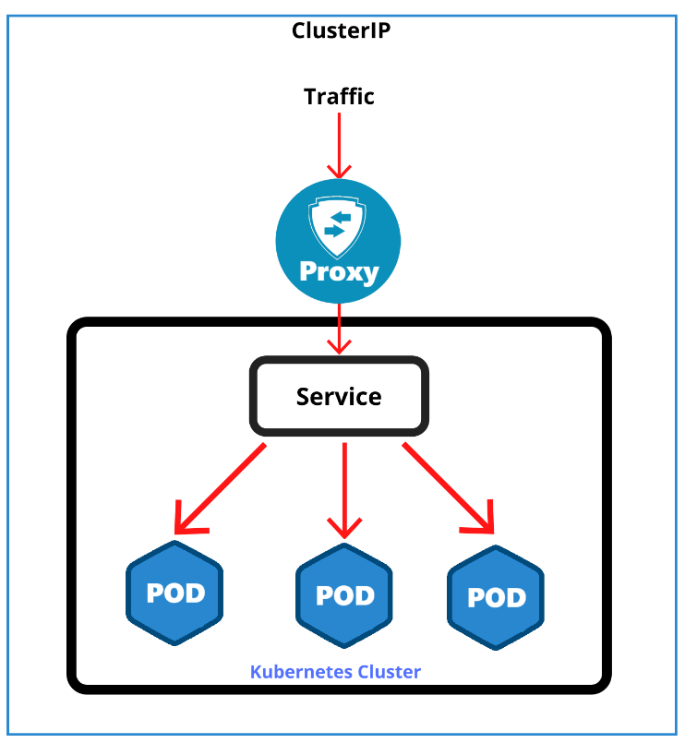
Figure 55: Kubernetes Service Architecture

Sealed Secret:
- What it is:
Secret Manager Operator in Kubernetes is a powerful tool for managing sensitive information securely. Sealed Secrets allow you to safely store and manage encrypted secrets in your version control systems. This ensures that sensitive data, such as passwords and API keys, are encrypted and can only be decrypted by the Kubernetes cluster. By using Sealed Secrets, you can achieve secure and versioned secret management, enhancing the security and robustness of your Kubernetes deployments. This approach simplifies the handling of secrets across different environments and improves overall security posture.
- How it works:
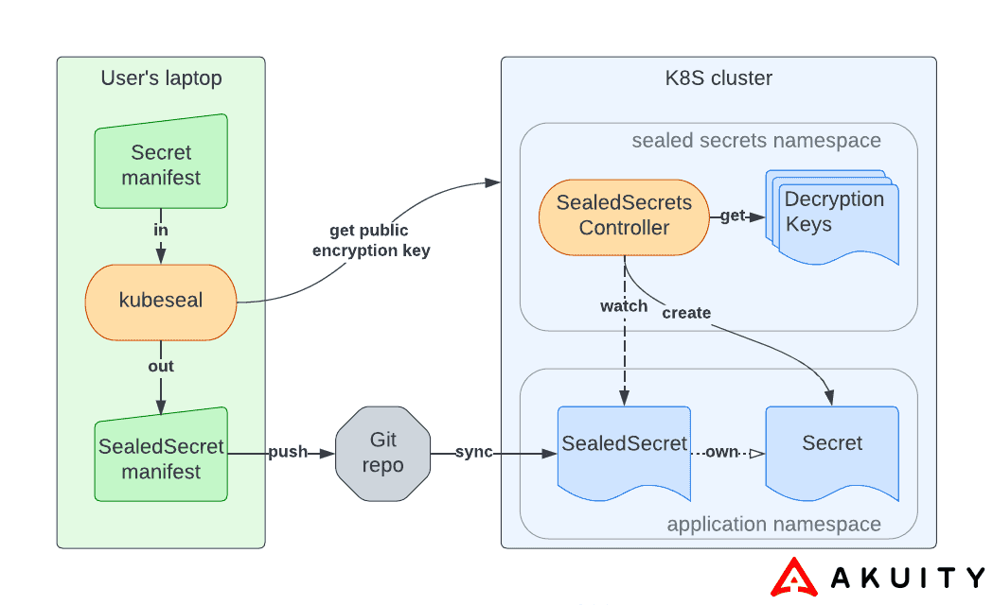
Figure 56: Sealed Secret Architecture

This architecture ensures that sensitive information, such as passwords and API keys, is securely managed throughout its lifecycle. By encrypting secrets on the developer's machine before committing them to version control, Sealed Secrets ensure that the secrets are never stored in plaintext, reducing the risk of accidental exposure. The Sealed Secrets Controller handles decryption within the Kubernetes cluster, ensuring that only authorized cluster components have access to the plain secrets. This approach enhances security, maintains confidentiality, and simplifies secret management in a Kubernetes environment

Helm Charts:
- Why Helm charts
Helm Charts are a powerful tool for managing Kubernetes applications and these are some reasons to use Helm Charts:
- Simplified Deployment: Helm packages Kubernetes manifests into a single chart, making it easier to deploy complex applications with a single command.
- Version Control: Helm allows you to version your deployments, facilitating rollbacks to previous versions in case of issues.
- Reusability: Helm charts can be shared and reused across projects, promoting consistency and saving time in application setup.
- Parameterization: Helm charts support configurable parameters, allowing for customization of deployments without modifying the underlying YAML files.
- Dependency Management: Helm handles dependencies between charts, ensuring all required services are deployed in the correct order.
- Environment Management: Helm makes it easy to deploy the same application to different environments (development, staging, production) with environment-specific configurations.
- Example:
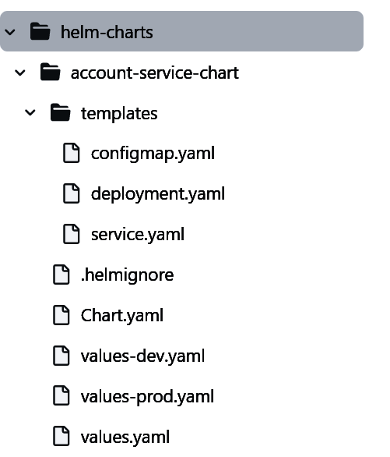
Figure 57: Helm Charts Example

Continuous delivery GitOps Tool

Argo CD:
Argo CD is a declarative, continuous delivery GitOps operator for Kubernetes. It is part of the Argo project, which provides solutions for orchestrating container workflows. Argo CD exemplifies the GitOps methodology, enabling the practical application of GitOps principles to manage Kubernetes environments effectively.
Argo CD continuously monitors your applications and compares the live state against the desired state, enabling automated deployments, rollbacks, and more.

Figure 58: Argo CD Logo
Its main features are:
- Declarative GitOps: Uses Git repositories as the source of truth for defining the desired state of applications and environments.
- Automated Sync: Continuously monitors the live state of applications and automatically syncs them with the desired state defined in Git.
- Rollback: Supports easy rollbacks to previous application versions in case of deployment failures.
- Multi-Cluster Support: Manages deployments across multiple Kubernetes clusters.
- Access Control: Provides fine-grained access control policies for managing application deployments.
- Customizable Workflows: Integrates with CI/CD pipelines to automate complex deployment workflows.
- Extensibility: Supports custom health checks, notifications, and integrations with other tools.
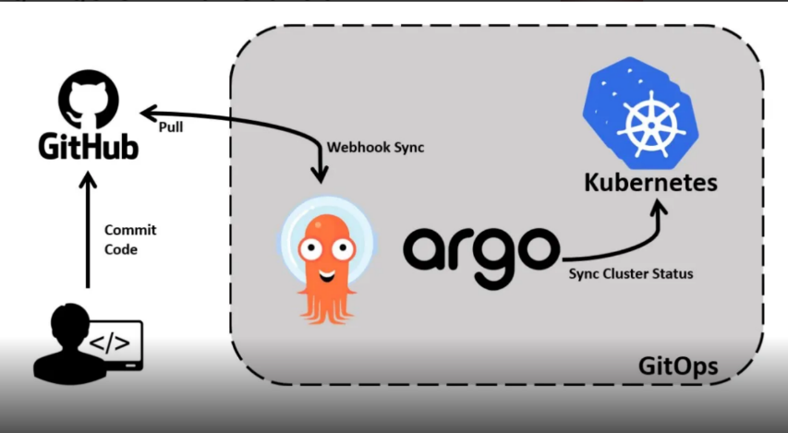
Figure 59: Argo CD Architecture

Automation Tool

Ansible:

Ansible is an open-source automation tool that simplifies configuration management, application deployment, and task automation.
- Ansible Playbooks: Ansible Playbooks allow users to define a series of tasks to be executed on remote hosts, enabling efficient infrastructure management.
- Calico CNI: Ansible can configure networking using Calico CNI, a powerful and scalable networking solution for Kubernetes clusters.
- CRI (Container Runtime Interface): Ansible supports managing container runtimes like CRI, ensuring seamless integration and management of containerized environments.
- Install Load Balancer: Ansible can be used to install load balancers, ensuring high availability and reliability of applications.
- Cluster K8 (Kubernetes Cluster): For Kubernetes cluster management, Ansible offers comprehensive solutions, enabling users to set up, configure, and maintain robust and scalable Kubernetes clusters efficiently

Figure 60: Ansible Logo
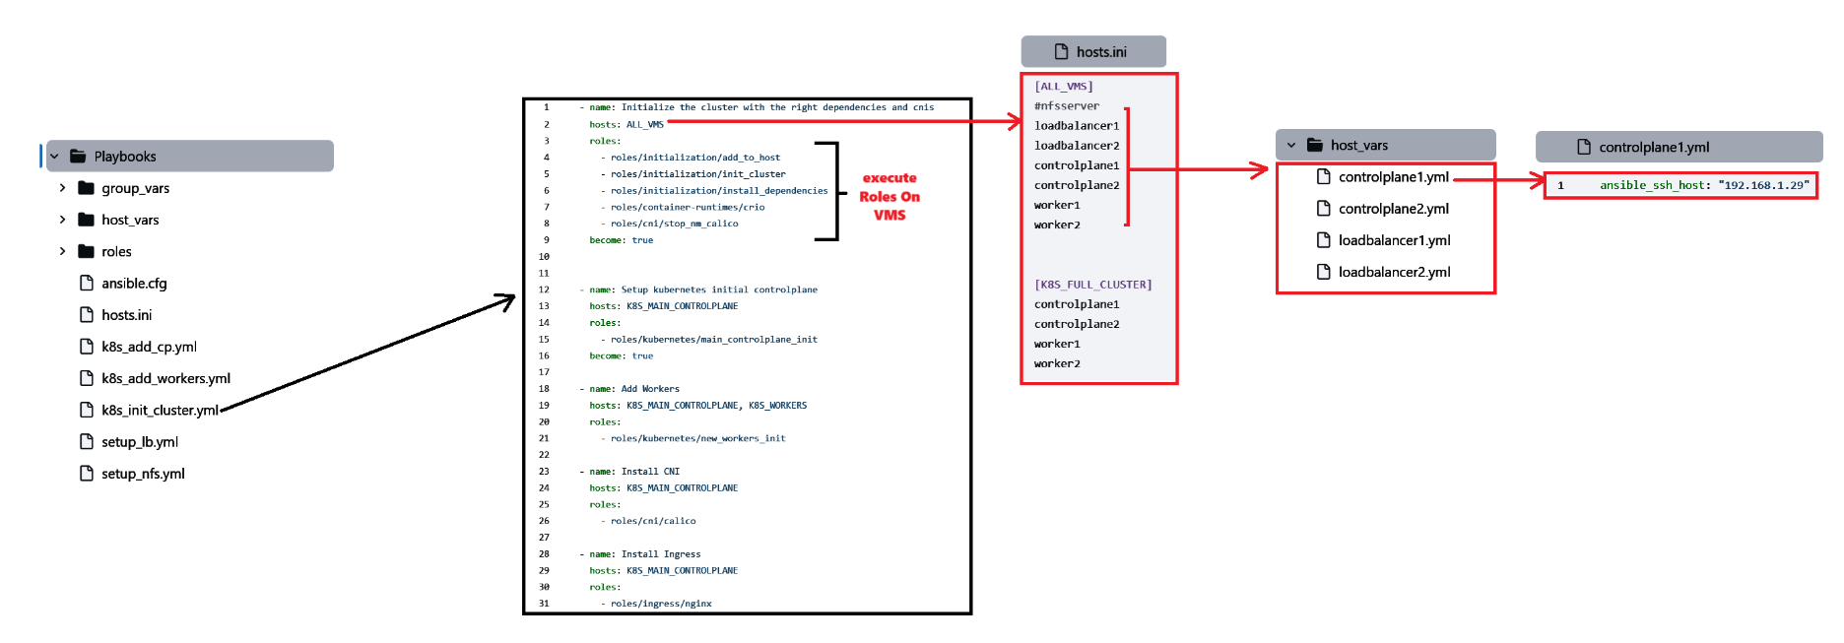
Figure 61: Ansible Playbooks Architecture

Proxy, Load balancing Tool

Nginx:
Nginx is a web server that can also be used as a reverse proxy, load balancer, mail proxy and HTTP cache.

Figure 62: Nginx Logo

Logs Management Tools

Filebeat and Elastic Stack:
- Filebeat:
- Lightweight shipper designed to forward and centralize log data.
- Installed as an agent on servers to monitor specified log files or locations.
- Collects log events and forwards them to Elasticsearch or Logstash for indexing.

- Elastic Stack (ELK Stack):
- Comprises Elasticsearch, Logstash, and Kibana.
- Enables efficient log analysis and visualization.
- Allows users to search, analyze, and visualize data in real-time.
- Provides a powerful solution for monitoring and observability.

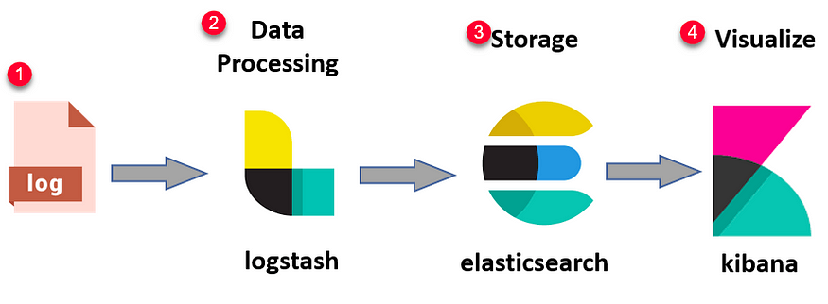
Figure 63: Elastic Stack

Prometheus and Grafana:
- Prometheus:
- Open-source monitoring and alerting toolkit.
- Designed for reliability and scalability.
- Collects and stores metrics as time series data.
- Provides powerful query language for retrieving and analyzing metrics.
- Supports multi-dimensional data collection and querying.


Figure 64: Prometheus Logo
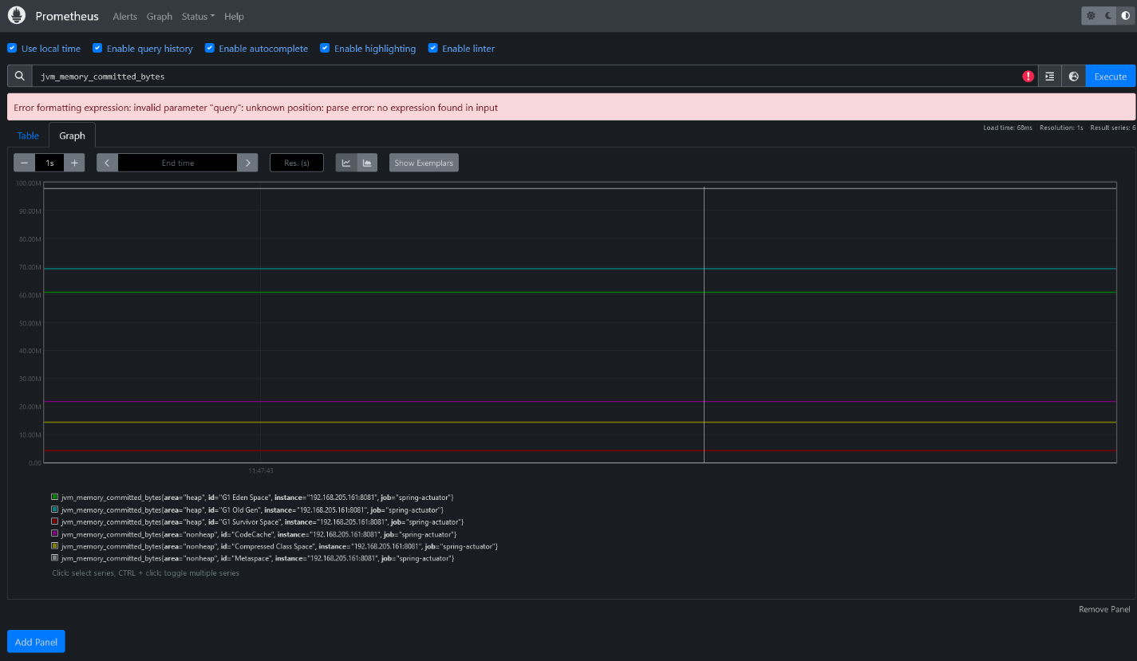
Figure 65: Prometheus Dashboard

- Grafana:
- Open-source platform for monitoring and observability.
- Visualizes data from multiple sources including Prometheus.
- Provides interactive dashboards and graphs.
- Supports alerting and notifications.
- Enables users to create custom queries and visualizations.

Figure 66: Grafana Logo

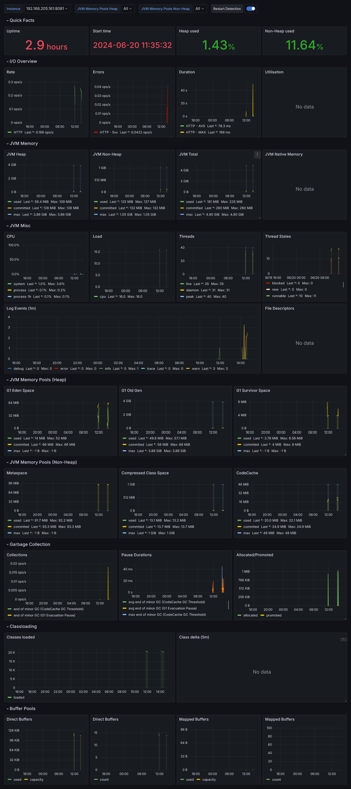
Figure 67: Grafana Dashboard

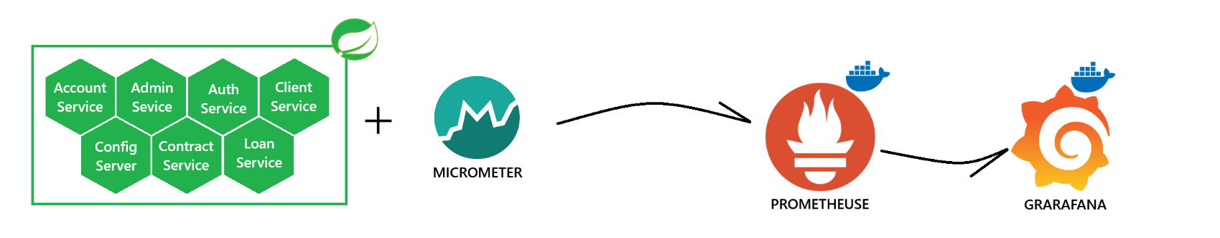
Figure 68: Spring / Prometheus / Grafana architecture
- Zipkin and Micrometer
- Zipkin:
- Open-source distributed tracing system.
- Helps in tracking the flow of requests through a distributed system.
- Collects and stores trace data.
- Provides insights into latency and dependencies.
- Useful for identifying performance bottlenecks and failures.
- Micrometer:
- Metrics instrumentation library for JVM-based applications.
- Provides a facade for various metrics backends (e.g., Prometheus, Graphite).
- Enables consistent collection and publication of application metrics.
- Integrates with frameworks like Spring Boot for seamless metrics exposure.
- Supports timers, counters, gauges, and distribution summaries for comprehensive metrics tracking.
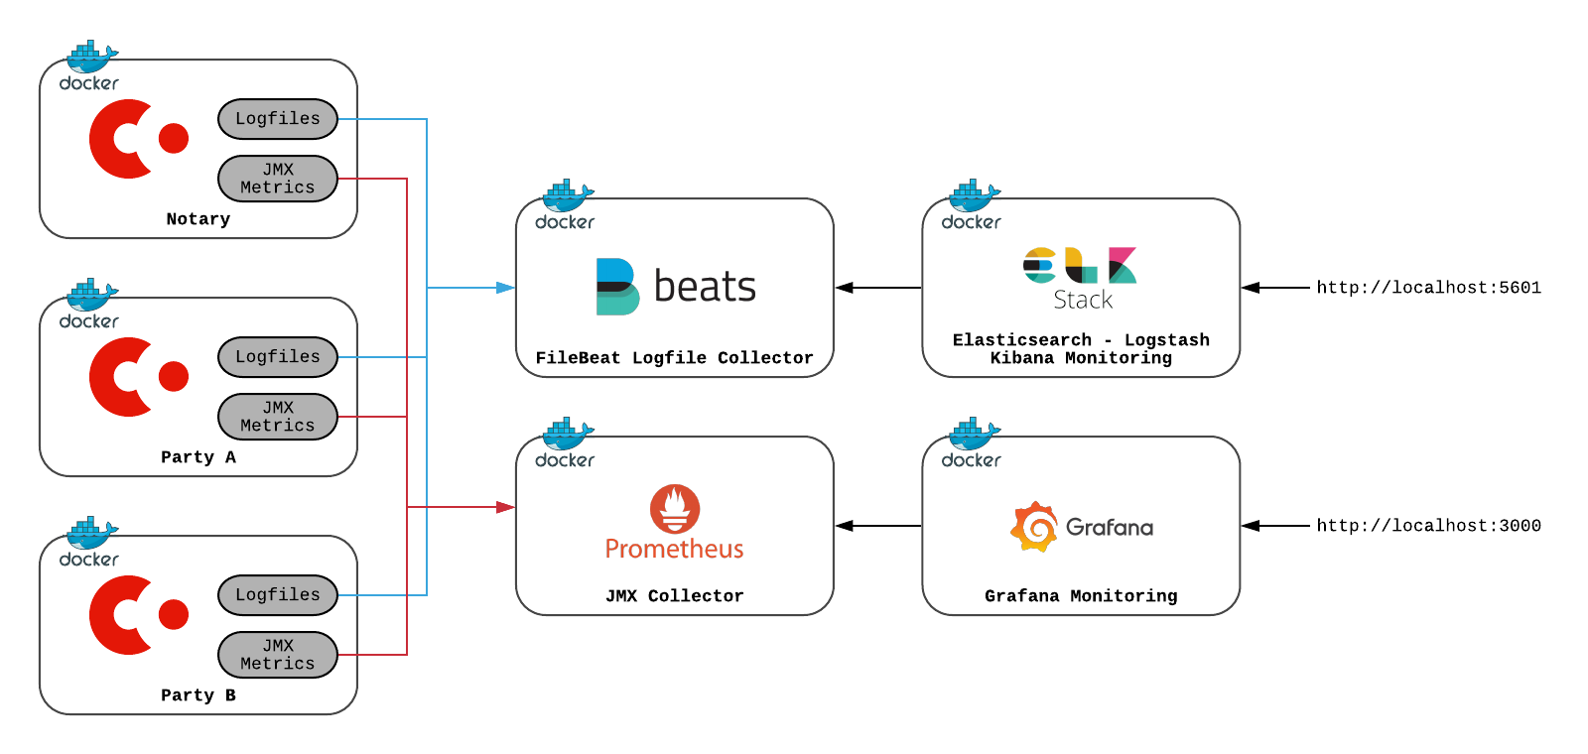
Figure 69: Logs Monitoring Architecture.

Static code Analytics Tool

SonarQube:
SonarQube is an open-source platform developed by SonarSource, designed for continuous inspection of code quality. It performs automatic reviews and static analysis to detect bugs, vulnerabilities, and code smells in Spring Boot Java applications. By integrating it with the project, SonarQube helps maintain high code standards, ensuring robust, clean, and maintainable code. It supports comprehensive analysis, offering insights and actionable recommendations across various aspects of code quality for 29 programming languages.


Figure 70: SonarQube Logo
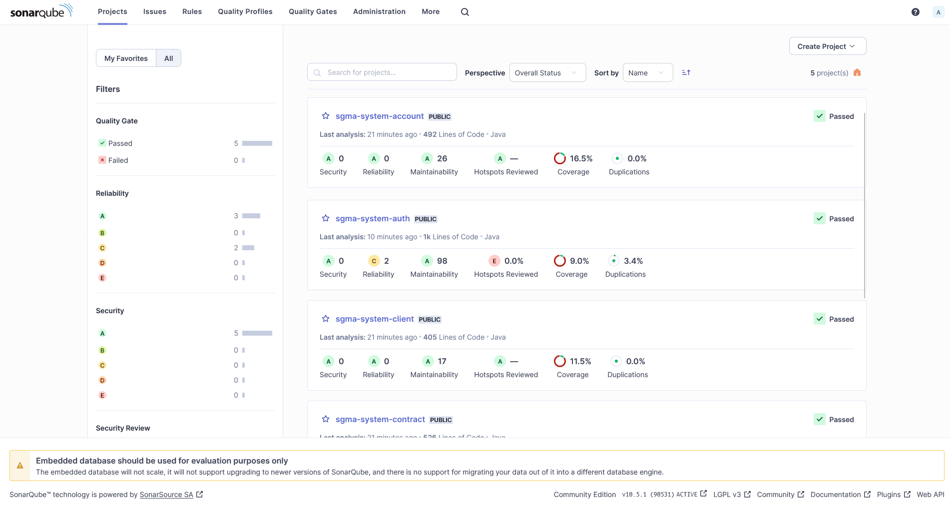
Figure 71: SonarQube Dashboard.

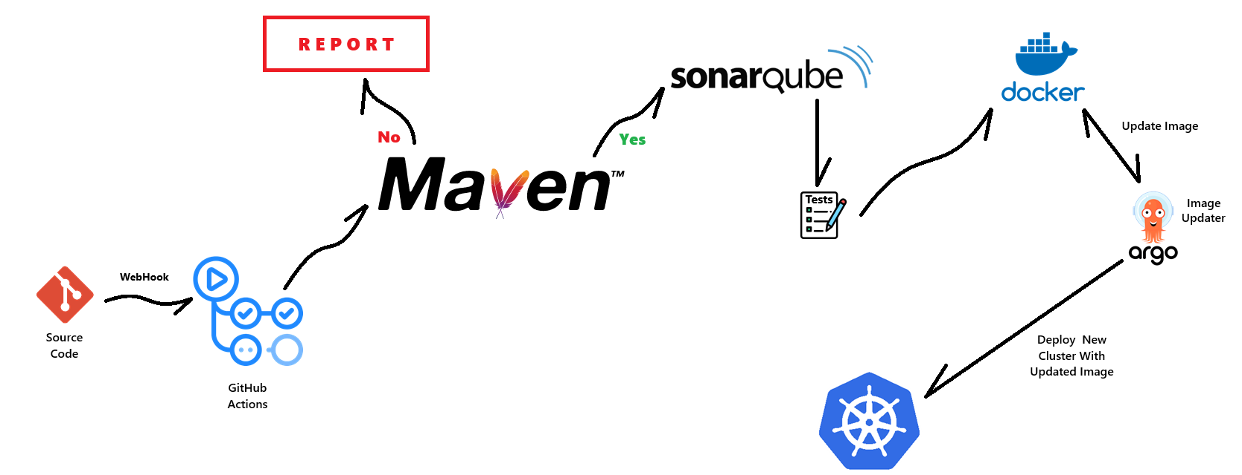
Figure 72: SonarQube Workflow.

integrating SonarQube into the CI/CD pipeline is a game changer. When developers push code changes to the Git repository, a webhook triggers GitHub Actions to start the workflow. the Maven compiles the source code, runs tests, and packages the Spring Boot application. If the build is successful, SonarQube performs static code analysis to detect bugs, vulnerabilities, and code smells. Code must pass SonarQube’s quality gates to proceed; otherwise, the process stops for developer review.
Once the code passes, a Docker image of the application is created, tagged, and pushed to a container registry. The Argo CD steps in to deploys the updated Docker image to a Kubernetes cluster. This pipeline ensures that only high-quality code is built, tested, and deployed, maintaining application reliability through continuous integration and deployment practices.
- Dev Environment
Focusing on our distributed system, we managed to integrate some common open source tools, proposing the following dev architecture:
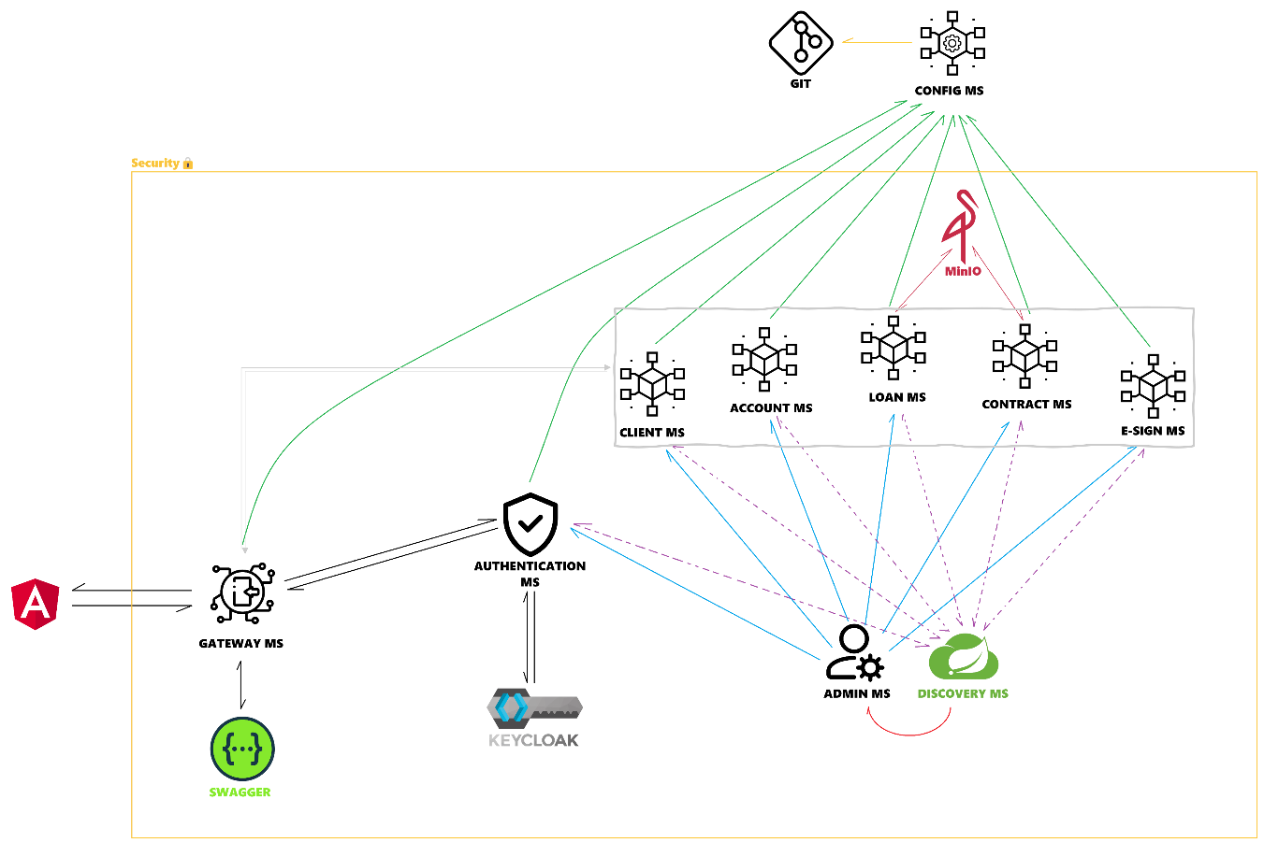
Figure 73: Dev Architecture.

- DevOps Environment
Focusing on our distributed system, we managed to integrate some common open source tools, proposing the following devops architecture:

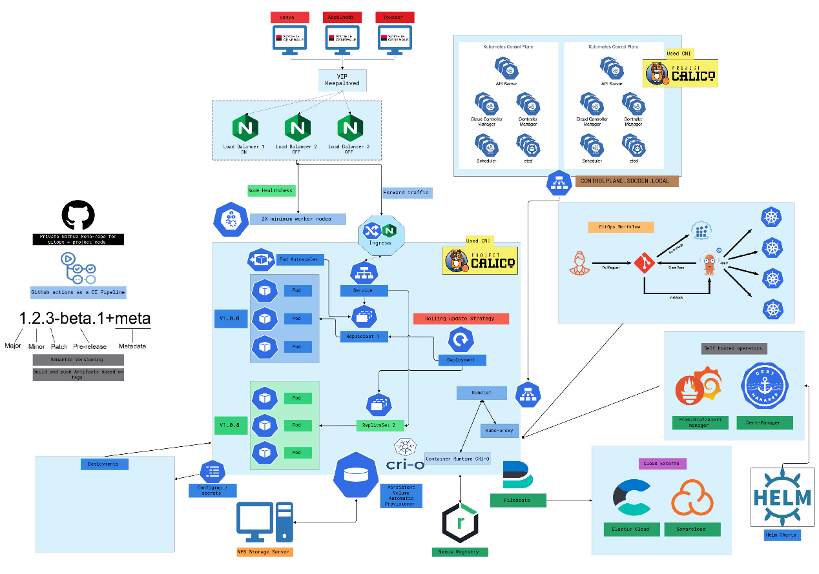
Figure 74: DevOps Architecture.

Graphical interfaces and Processes:

The graphical user interface (GUI) holds a paramount importance in the design process of an application as it provides a pleasant user experience throughout their navigation. Consequently, this factor has the potential to differentiate between two applications even if they share similar functionalities. Here is a series of screenshots illustrating key entry points of the application:

Authentication Process:
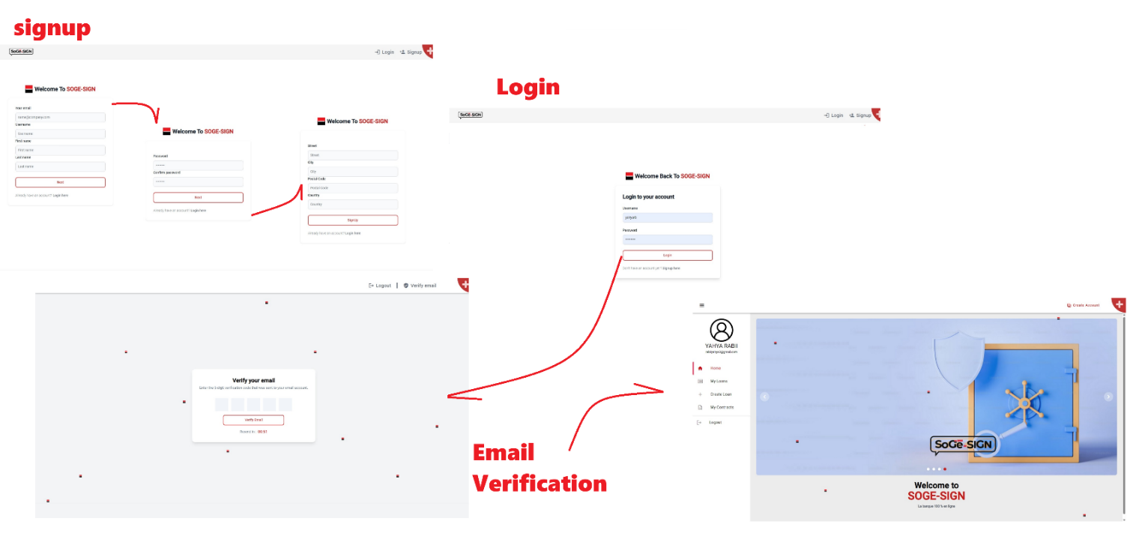
Figure 75: Authentication process
- Workflow Description:
1. Signup Page:
- The user is prompted to enter their email, username, first name, and last name.
- After filling out these details and clicking "Next," the user proceeds to the next step.

2. Password Setup:
- The user is prompted to create and confirm a password.
- After setting the password and clicking "Next," the user proceeds to the next step.

3. Address Information:
- The user is prompted to enter their address details, including street, city, postal code, and country.
- After filling out these details and clicking "Signup," the user is directed to the email verification step.

4. Email Verification:
- The user is required to verify their email address by entering a 5-digit verification code sent to their email.
- After entering the code and clicking "Verify Email," the user completes the signup process.

5. Login Page:
- Existing users can log in by entering their username and password.
- After logging in, the user is directed to the main application interface.

Bank Account Creation Process:
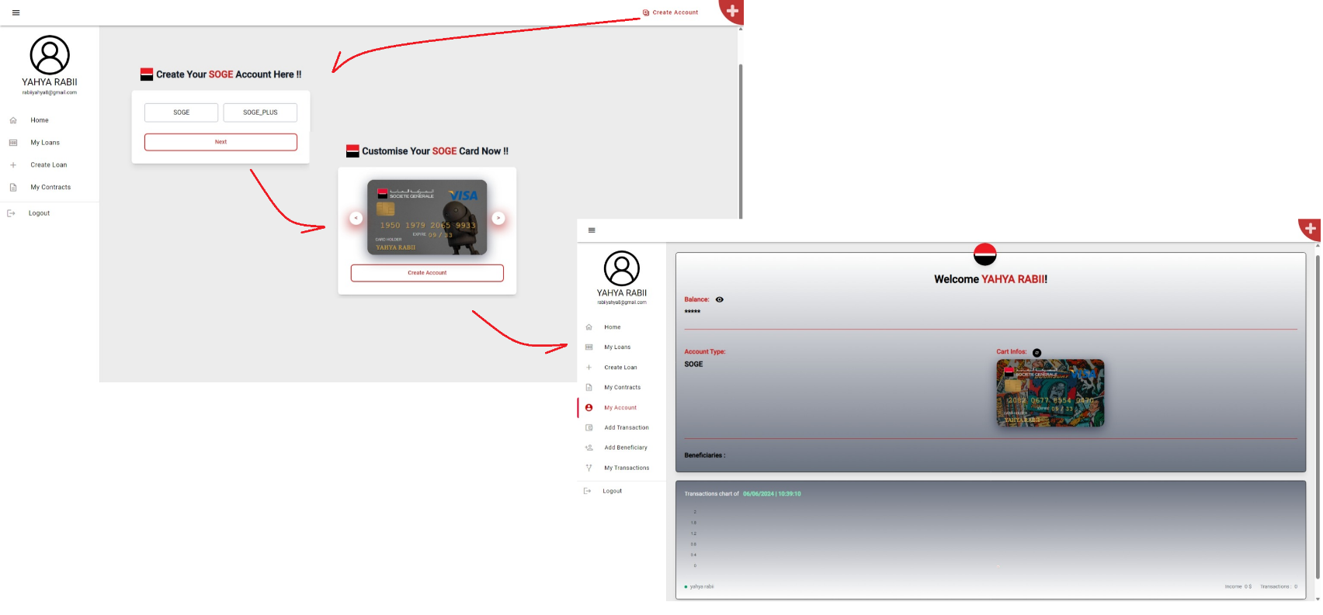
Figure 76: Bank Account Creation Process
- Workflow Description:
1. Create Account Page:
- The user is prompted to choose between two account types: "SOGE" and "SOGE_PLUS."
- After selecting an account type and clicking "Next," the user proceeds to customize their card.

2. Customize Card Page:
- The user is presented with a card customization interface where they can design their card.
- After customizing the card and clicking "Create Account," the user is directed to their account dashboard.

3. Account Dashboard:
- The dashboard displays a welcome message with the user's name.
- It shows account details, including balance (hidden for privacy), account type ("SOGE"), and card information.
- The sidebar provides navigation options such as "Home," "My Loans," "Create Loan," "My Contracts," "My Account," "Add Transaction," "Add Beneficiary," "My Transactions," and "Logout."
- The main section of the dashboard includes a transactions chart and a section for beneficiaries, with the current balance and recent transactions.

Loan Request Process
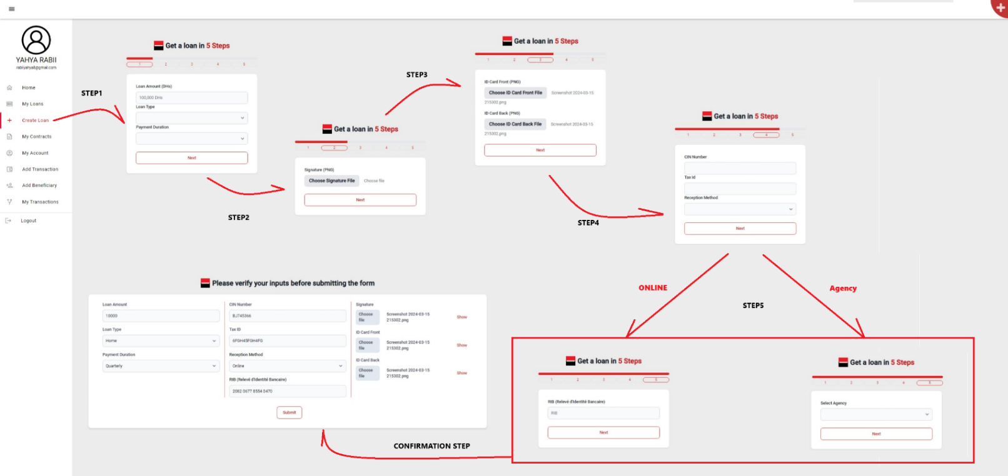
Figure 77: Loan Request Process
- Workflow Description:
1. Loan Details:
- The user is prompted to enter the loan amount (in Dirhams), loan type, and payment duration.
- After filling out these details and clicking "Next," the user proceeds to the next step.

2. Upload Signature:
- The user is required to upload a digital signature file (PNG format).
- After uploading the signature and clicking "Next," the user proceeds to the next step.

3. Upload ID Card:
- The user is required to upload the front and back images of their ID card (PNG format).
- After uploading the ID card images and clicking "Next," the user proceeds to the next step.

4. Personal Information:
- The user is prompted to enter their CIN number, tax ID, and reception method.
- After filling out these details and clicking "Next," the user proceeds to the final step.

5. Reception Method:
- Depending on the chosen reception method, the user is directed to one of two sub-steps:
- Online: The user enters their RIB.
- Agency: The user selects the agency where they want to receive the loan.
- After completing the appropriate sub-step and clicking "Next," the user proceeds to the confirmation step.

6. Confirmation Step:
- The user is presented with a summary of all the entered details, including loan amount, loan type, payment duration, CIN number, tax ID, reception method, and uploaded files (signature, ID card front and back).
- The user is prompted to verify all the inputs before submitting the form.
- After verifying the details and clicking "Submit," the loan application process is completed.

Loan Validation Process
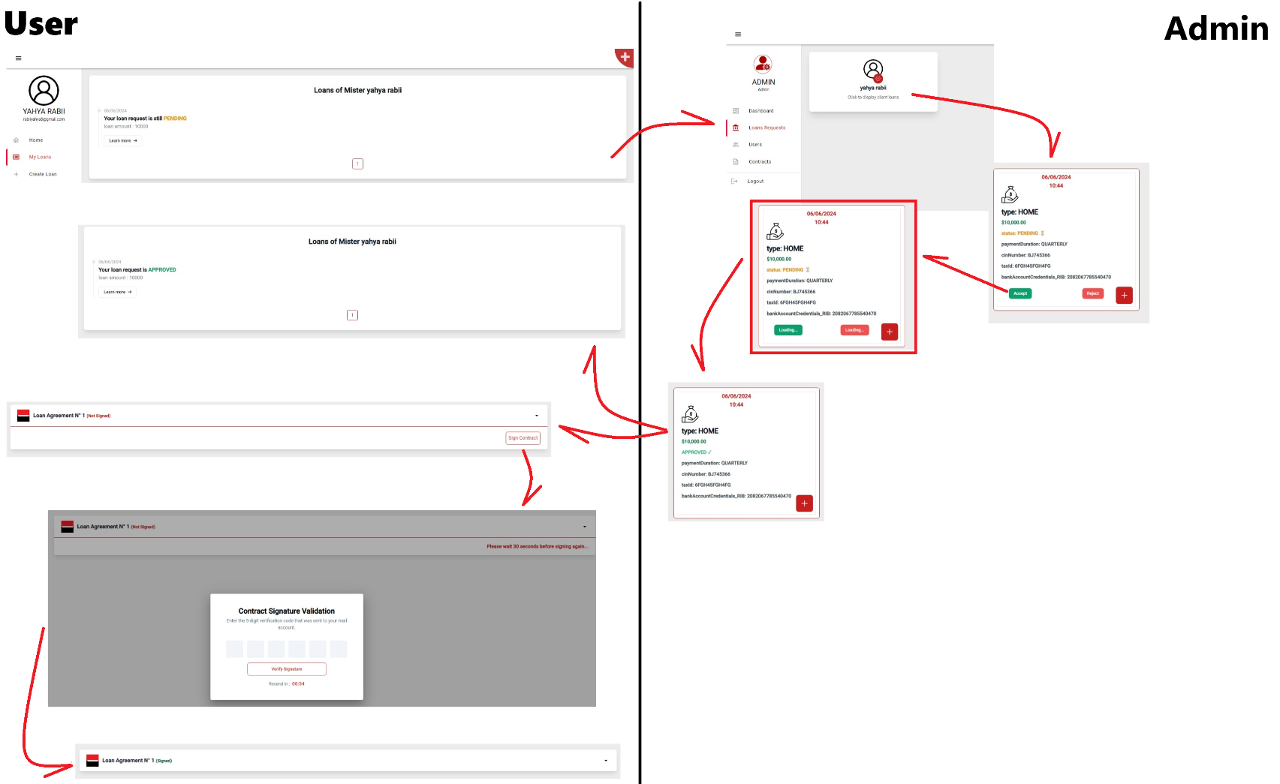
Figure 78: Loan Validation Process
- Workflow Description:
User Flow

1. Loan Request Status (Pending):
- The user views the status of their loan request, which is initially marked as "Pending."
- The screen shows the loan amount and type with a "Learn more" button.

2. Loan Request Status (Approved):
- Once the loan is approved, the status updates to "Approved."
- The screen displays the approved loan amount and type with a "Learn more" button.

3. Loan Agreement:
- The user is prompted to sign the loan agreement.
- The agreement status shows as "Not Signed" initially, with a button to "Sign Contract."

4. Contract Signature Validation:
- The user enters a 5-digit verification code sent to their email to validate their signature.
- After entering the code and clicking "Verify Signature," the contract status updates to "Signed."

Admin Flow

5. Loan Requests Overview:
- The admin dashboard displays loan requests with options to view details, approve, or reject requests.
- The admin selects a specific loan request for more details.

6. Loan Request Details (Pending):
- The admin views detailed information about the loan request, including the type, amount, payment duration, and user details.
- The admin can approve or reject the request using the "Approve" or "Reject" buttons.

7. Loan Request Details (Approved):
- Once the admin approves the loan request, the status updates to "Approved."
- The admin can still view detailed information about the loan and user, with the option to manage the loan further.

Add Beneficiary Process
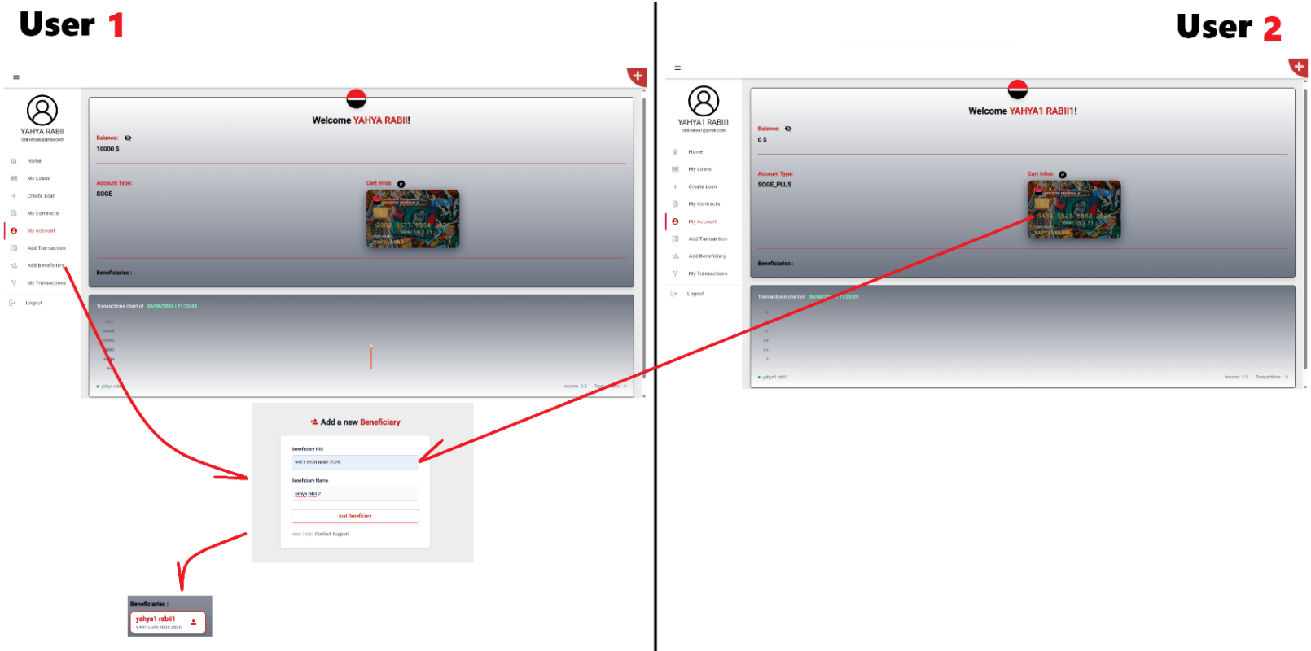
Figure 79: Add Beneficiary Process
- Workflow Description:
User Flow
1. Account Overview:
- User 1 views their account dashboard, showing a balance of $10,000 and account type "SOGE."
- The screen displays the user's card information and a section for beneficiaries (currently empty).
2. Add Beneficiary:
- User 1 navigates to the "Add Beneficiary" section using the sidebar menu.
- The user enters the beneficiary's RIB (account number) and name in the provided fields.
- After entering the details, User 1 clicks "Add Beneficiary."
3. Beneficiary Added:
- The new beneficiary is now listed under the "Beneficiaries" section in User 1's account overview.
- The beneficiary's RIB is displayed, confirming the addition.
User 2 Flow
3. Account Overview:
- User 2 views their account dashboard, showing a balance of $0 and account type "SOGE_PLUS."
- The screen displays the user's card information and a section for beneficiaries (currently empty).
4. Beneficiary Added:
- The new beneficiary added by User 1 is now reflected in User 2's account.
- The beneficiary's RIB is displayed in the "Beneficiaries" section, confirming the addition from User 1's side.

Add Transaction Process
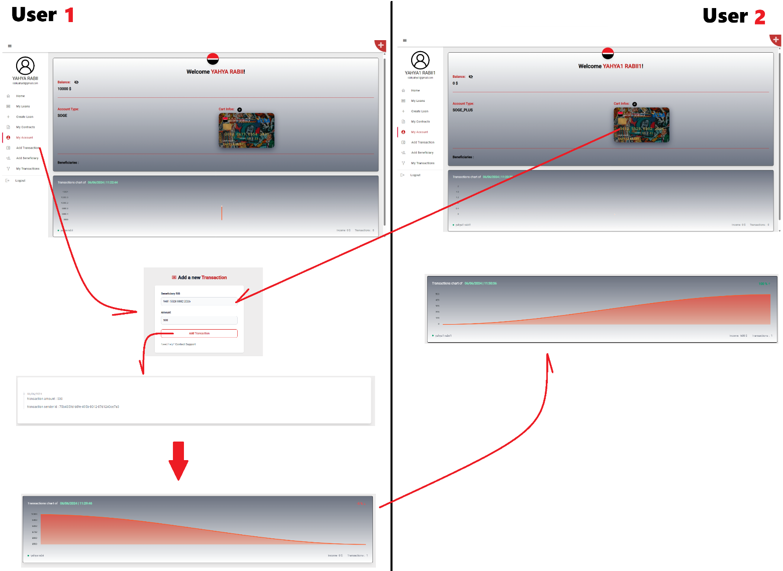
Figure 80: Add Transaction Process
- Workflow Description:
User Flow
1. Account Overview:
- User 1 views their account dashboard, showing a balance of $10,000 and account type "SOGE."
- The screen displays the user's card information and a section for beneficiaries.
2. Add Beneficiary:
- User 1 navigates to the "Add Transaction" section using the sidebar menu.
- The user enters the beneficiary's RIB, the amount of the transaction ($100), and a description.
- After entering the details, User 1 clicks "Add Transaction."
3. Beneficiary Added:
  - The transaction details, including the amount and the date and time of the transaction, are displayed.
  - The user's transaction chart is updated to reflect the new transaction, showing the balance after the transaction is made.

User 2 Flow
1. Account Overview:
- User 2 views their account dashboard, showing a balance of $0 and account type "SOGE_PLUS."
- The screen displays the user's card information and a section for beneficiaries.
2. Add Beneficiary:
- User 2's transaction chart is updated to reflect the received transaction.
- The chart shows the updated balance and the details of the transaction from User 1.

Conclusion:

The last section was dedicated to navigation within the application. It serves as the final part of this report and is intended to present the software and hardware environment of implementation. It also describes the main functionalities that were implemented after development, accompanied by screenshots illustrating the key interface elements of the application.

GENERAL CONCLUSION

Contributing to the creation of this platform has been an exceptional opportunity that allowed me to gain practical professional experience in the field of web application development using Spring Boot and microservices. This experience has been deeply enriching on multiple levels. By putting my theoretical knowledge into practice, this project not only helped me solidify my understanding but also anchored it in a real and tangible context. I deepened my programming language and platform skills, successfully exploring and leveraging them.
This report diligently details the various essential steps in designing and developing this innovative platform. Moreover, this endeavour served as an invaluable opportunity to acquire new skills, particularly in the expert use of Angular, DevOps practices, Kubernetes, and Ansible. By mastering these tools, I further solidified my programming language skills and related technologies, notably Java and Spring Boot.
Undoubtedly, these newly acquired skills will play a pivotal role in my future professional experiences, providing me with a distinct advantage in the job market, especially in the banking sector where Agile methodologies are highly valued.


This internship has been an exceptional professional experience.
University life certainly provides a glimpse into our future careers, but it quickly becomes evident that practice often surpasses theoretical knowledge, offering an accelerated and concrete form of learning.

THE END

References

SonarQube: https://docs.sonarqube.org

MinIO: https://docs.min.io

Keycloak: https://www.keycloak.org/documentation.html

Keycloak RestApi : https://www.keycloak.org/docs-api/21.0.0/rest-api/index.html

GitHub Actions: https://docs.github.com/en/actions

Spring Boot: https://docs.spring.io/spring-boot/docs/current/reference/htmlsingle

Spring Security: https://docs.spring.io/spring-security/reference/

Spring Cloud: https://spring.io/projects/spring-cloud

OpenAPI: https://swagger.io/specification

Docker: https://docs.docker.com

DockerHub: https://hub.docker.com/

Flaticon: https://www.flaticon.com

ChatGPT: https://chatgpt.com/

Stack Overflow: https://stackoverflow.com

Stack Exchange: https://stackexchange.com

Grafana: https://grafana.com/docs/grafana/latest

Prometheus: https://prometheus.io/docs

ELK Stack: https://www.elastic.co/guide/index.html

